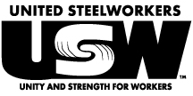
USW LOCAL 2-232

JULY 2021 MEMBERSHIPMEETING

SUNDAY, JULY 18th, 2021
@ 9:30 a.m.
Milwaukee Area Labor Council Building
633 S. Hawley Road
Yatchak Hall

Important Business

- Reports of Officers, Reps and Committees
- By-Law Changes to be Read (3rd and final) and voted on
- Discussion and action on all other proper business for the meeting

