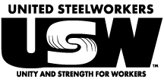
USW LOCAL 2-232

RESCHEDULED
SPECIAL TRIAL
MEETING

FRIDAY, OCTOBER 25TH, 2019
4:00 p.m.

Milwaukee Area Labor Council Building
633 S. Hawley Road Milwaukee, WI 53214
Yatchak Hall West

Important Business

- Trial of a Member or Local Union Officer

*Please note: As this is a Special Membership Meeting, this will be the only business conducted*

