Brothers and Sisters, it continues to look like the year 2020 is the year of obstacles. We are still fighting the Covid-19, but now with the added wildfires causing much smoke and heat we must ensure the safety of ourselves and our families.

My thoughts and prayers are with our brothers and sisters that had to evacuate their homes and now live in the fear that everything has or could be lost.

During these times of high stress and worry we all need to keep a watch out for everyone's safety. If you see someone not looking well or is doing something unsafe, we need to immediately talk with them to get their mind back in the game.

Use the 3 second rule if you feel like you are getting overheated, take a water brake, go to a cool area. If you are having a harder time breathing with the mask on, take a step away from others and pull it down and take a breather.

The heat and smoke we are dealing with right now is going to make things harder but you must remember to stay safe and not cut corners that can possibly get you or someone else hurt by trying to save time.

As of now the Union meetings have still been canceled because of social distancing. I have been in talks with our international staff rep on when we can resume our meetings and how things need to be handled. Once we are able to resume there will be notice posted of the meeting date and time. As always with union meeting or without, if you have any questions or concerns please send me an email at salazar.usw1440@gmail.com

In Solidarity, Ben Salazar

**Presidents letter**

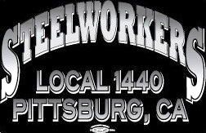

**Retirements:**

**Lucero, Milton – 47 Years**

**OP Tech - PLTCM Rolling 7/9/1973 - 08/17/2020**

**Brown, Anthony – 43 Years**

**OP Tech** - **PLTCM/Rolling 5/23/1977 -** **08/07/2020**

**We Want to Wish our Union Members A prosper and Healthy Retirement**

Union Meetings Are

**Postponed till further notice**

677 Cumberland Street

Pittsburg, CA 94565

Phone: 925-432-7396

* Almost 69 percent (80 million tons) of steel is recycled in North America each year, which is more than paper, aluminum, plastic, and glass combined.
* The steel industry has an estimated $900 billion turnover, making it the second largest industry in the world after oil and gas.
* Steel bridges are four to eight times lighter than those built from concrete. The Golden Gate Bridge (1937) required 83,000 tons of steel whereas half of that amount would be required today.
* More than 600 steels cans are recycled every second in the United States.
* Recycling a single steel can saves enough energy to power a 60-watt light bulb for almost 4 years.
* Steel birthed the first skyscraper: Chicago’s ten-story, 138-foot Home Insurance Building. The steel framework allowed the building to rise higher than any building, supporting the weight on thin steel columns rather than on stone walls.

**Hot off the press News!**

Our Local email Blast can be signed up for by

* Go to: **uswlocals.org/local-1440**
* Click on the link “stay updated”
* Fill out the form and Submit.



**Wage Safety**

**HEAT AND HYDRATION**

Why is hydration so important? Your body depends on water to survive. Every cell, tissue, and organ in your body needs water to work properly. For example, your body uses water to maintain its temperature, remove waste, and lubricate your joints. Water is needed for overall good health. Sports drinks can be helpful if you’re planning on exercising at higher than normal levels for more than an hour. They contain carbohydrates and electrolytes that can increase your energy. They help your body absorb water. However, some sports drinks are high in calories from added sugar. They also may contain high levels of sodium (salt). Check the serving size on the label. One bottle usually contains more than one serving. Some sports drinks contain caffeine, too. Remember that a safe amount of caffeine to consume each day is no more than 400 milligrams. Energy drinks are not the same as sports drinks. Energy drinks usually contain large amounts of caffeine. Also, they contain ingredients that overstimulate you (guarana, ginseng, or taurine). These are things your body doesn’t need.

**Staying hydrated is difficult for you, here are some tips that can help:**

* Keep a bottle of water with you during the day.

To reduce your costs, carry a reusable water bottle and

fill it with tap water.

* If you don’t like the taste of plain water, try adding a

slice of lemon or lime to your drink.

* Drink water before, during, and after a workout.
* When you’re feeling hungry, drink water. Thirst is often

confused with hunger. True hunger will not be satisfied

by drinking water. Drinking water may also contribute to

a healthy weight-loss plan. Some research suggests that

drinking water can help you feel full.

* If you have trouble remembering to drink water, drink on

a schedule. For example, drink water when you wake up,

at breakfast, lunch, and dinner, and when you go to bed.

Or, drink a small glass of water at the beginning of each

hour.

* Drink water when you go to a restaurant. It will keep you hydrated.
* https://familydoctor.org/hydration-why-its-so-important

**In Solidarity, Your Wage Safety Representatives**

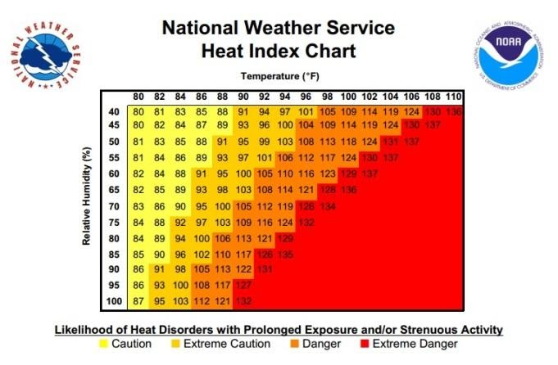

UNION NEWS

**Steel keeps the trains running on time – literally.**

The partnership between the steel industry and the rail car industry spans centuries and built America, and today impacts millions of jobs in manufacturing and the supply chain. But here in Washington, D.C., the city’s Metrorail transit system – which receives hundreds of thousands of federal dollars – is trying to use accounting loopholes to sidestep the laws that require that the steel that goes into their rail cars is Made in America.

The federal government’s Buy America rules for transit spending ensure that 70 percent of the cost of parts are Made in America. These rules are especially important now, when the COVID-19 pandemic has forced plant closures and presented tremendous challenges to the economy.

But the Washington Metropolitan Area Transit Authority (WMATA) is trying to get around those laws in order to import foreign-made rail cars.

You and I can't let that happen. The jobs of the workers in the steel and other industries should not be put at further risk to enable the D.C. transit agency to buy foreign subway cars, possibly with parts from China and elsewhere.

Please send a message to WMATA and tell them that you want your tax dollars to go to American-made rail cars.

Thanks,

Kevin Dempsey

Interim President and CEO

American Iron and Steel Institute

**Deliver Some Solidarity: Contact Congress and urge them to save our Postal Service.**

For two hundred years, the United States Postal Service (USPS) has provided the essential communication services to bind our Nation together through some of its most trying times – including our current pandemic.

However, recent changes in overtime and the removal of sorting equipment are adding unnecessary burdens on our postal system. And, a 2006 law that forces the postal service to pre-fund 70 years of retiree benefits - a demand that is not made of any other federal agency nor the private sector -- is bankrupting one of the Nation’s oldest and most reliable services. Postal Workers need urgent support - let's show them the Steelworkers have their backs.

Here are a few things you should know about one of the oldest and very few government agencies specifically mentioned (and authorized) in the Constitution:

**\***Veterans: The Postal Service employs more than 97,000 military veterans and is one of the largest employers of veterans in the country.

**\*** Heroes: Postal employees regularly go beyond the call of duty to protect the lives of customers they serve, including older and disabled customers. These workers are part of our communities – we know them by name – they are an integral part of the middle class.

**\*** Greener than you think: the paper for free Priority Mail boxes comes from well-managed forests and include at least 30-percent recycled content. Another bonus? Those boxes are made in USW facilities by our members.

**\*** Dependable: The Postal Service is the only organization in the country that has the resources, network infrastructure, and logistical capability to regularly deliver to every residential and business address in the nation.

**\*** Security: U.S. Mail is protected by more than 200 federal laws enforced by the Postal Inspection Service, one of the nation's oldest law enforcement agencies.

**\***Zero tax dollars used: The Postal Service receives NO tax dollars for operating expenses. Because of this, it is mandated to run much like a private business, generating its income from the sale of postage, products, and services to fund its operations.

You can also contact your Representative by dialing 866-202-5409 and your Senators by dialing 877-607-0785.

NOTE: Your zip code will direct you to your Member of Congress. Tell the office who you are and where you are from, and ask them to step in and provide the postal funding that our communities need. Be sure to make a second call to the Senate number so you can speak to both.

unity****strength****respect****united****steelworkers