**Presidents letter**

USW is hosting its first ever virtual education conference for the

NEXT GEN program to get our younger Brothers and Sisters involved in the Union.

If anyone is interested in the NEXT GEN program please call the union hall.

Classes include but not limited to: Introduction to Collective Bargaining,

Assessing Hazards At Work, Financial Officer Training,

Roles of Stewards, Arbitration, New Media and Communications,

Legislative, Union Basics, Civil and Human Rights.

We have received notice from Contra Costa county that we are reentering

the red zone for Covid-19 health and safety, this is due to positive case

numbers that are on the rise. I will be in touch with our International rep

to see how this will affect our local union, and if we can continue having

our monthly meetings. UPI will continue to operate “business as usual”

and we will be in continuous contact with the company to make sure we

are informed on any possible changes.

Safety has to be top priority all of the time, but with everything going on

in the world today we all need to take a step back and keep a clear head.

No matter what the task we need to perform. The holidays are here so it

is very easy to be distracted with our minds on countless other things.

When we become distracted that is when people lose track of what they

are doing and the unbearable happens.

**I would like to wish**

**everyone and their families a**

**happy and safe Thanksgiving.**

**In Solidarity, Ben Salazar**

**I CHOSE TO LOOK THE OTHER WAY**

**I could have saved a life that day**

**But I chose to look the other way.**

**It wasn't that I didn't care,**

**I had the time and I was there**

**But I didn't want to seem a fool,**

**or argue over a safety rule.**

**I knew he'd done the job before**

**If I spoke up he might get sore.**

**The chances didn't seem that bad**

**I'd done the same, he knew I had,**

**So I shook my head and walked on by,**

**He knew the risks as well as I.**

**He took the chance, I closed an eye,**

**And with that act, I let him die.**

**I could have saved a life that day,**

**But I chose to look the other way.**

**Now every time I see his wife,**

**I'll know I should have saved his life.**

**That guilt is something I must bear,**

**But it isn't something you need share.**

**If you see a risk that others take,**

**That puts their health or life at stake,**

**The question asked or thing you say**

**Could help them live another day.**

**If you see a risk and walk away**

**Then hope you never have to say,**

**I could have saved a life that day**

**But I CHOSE to look the other way**

**Author: DON MERRILL**

**Brought to you by your wage safety reps.**



**Looking for more Union Info?**

**Our local union has a web site!!**

**Did you miss last month’s Filer?**

**Looking for a form?**

**Heard about an event?**

**Want to sign up for email alerts?**

**All of this and more can be found online at:**

**uswlocals.org/local-1440**

Union Meetings Are

**Dec. 10th**

677 Cumberland Street

Pittsburg, CA 94565

Phone: 925-432-7396

Mask Required, 25 people Allowed.

**Top 10 safety tips**

* Stay in the kitchen when you are cooking on the stove top so you can keep an eye on the food.
* Stay in the home when cooking your turkey, and check on it frequently.
* Keep children away from the stove. The stove will be hot and kids should stay three feet away.
* Make sure kids stay away from hot food and liquids. The steam or splash from vegetables, gravy or coffee could cause serious burns.
* Keep knives out of the reach of children.
* Be sure electric cords from an electric knife, coffee maker, plate warmer or mixer are not dangling off the counter within easy reach of a child.
* Keep matches and utility lighters out of the reach of children — up high in a locked cabinet.
* Never leave children alone in room with a lit candle.
* Keep the floor clear so you don’t trip over kids, toys, pocketbooks or bags.
* Make sure your smoke alarms are working. Test them by pushing the test button.

**Thanksgiving fire facts**

* Thanksgiving is the peak day for home cooking fires, followed by Christmas Day, the day before Thanksgiving, Easter, and Christmas Eve.
* In 2018, U.S. fire departments responded to an estimated 1,630 home cooking fires on Thanksgiving, the peak day for such fires.
* Unattended cooking was by far the leading contributing factor in cooking fires and fire deaths.
* Cooking caused almost half of all reported home fires and home fire injuries, and it is the second leading cause of home fire deaths in 2014-2018.

**Holiday Fire Danger**

**Host a virtual Thanksgiving meal with friends and family who don’t live with you**

• Schedule a time to share a meal together virtually.

• Have people share recipes and show their turkey, dressing, or other dishes they prepared.

**Watch television and play games with people in your household**

• Watch Thanksgiving Day parades, sports, and movies at home.

• Find a fun game to play.

**Shopping**

• Shop online sales the day after Thanksgiving and days leading up to the winter holidays.

• Use contactless services for purchased items, like curbside pick-up.

• Shop in open air markets staying 6 feet away from others.

**Other Activities**

• Safely prepare traditional dishes and deliver them to family and neighbors in a way that does not involve contact with others (for example, leave them on the porch).

• Participate in a gratitude activity, like writing down things you are grateful for and sharing with your friends and family

**If having guests to your home, be sure that people follow the steps that everyone can take to make Thanksgiving safer. Other steps you can take include:**

• Have a small outdoor meal with family and friends who live in your community.

• Limit the number of guests.

• Have conversations with guests ahead of time to set expectations for celebrating together.

• Clean and disinfect frequently touched surfaces and items between use.

• If celebrating indoors, make sure to open windows.

• Limit the number of people in food preparation areas.

• Have guests bring their own food and drink.

• If sharing food, have one person serve food and use single-use options, like plastic utensils.

**Make your celebration safer. In addition to following the steps that everyone can take to make Thanksgiving safer, take these additional steps while attending a Thanksgiving gathering.**

• Bring your own food, drinks, plates, cups, and utensils.

• Wear a mask, and safely store your mask while eating and drinking.

• Avoid going in and out of the areas where food is being prepared or handled, such asin the kitchen.

• Use single-use options, like salad dressing and condiment packets, and disposable items like food containers, plates, and utensils.

**Wear a mask**

• Wear a mask with two or more layers to stop the spread of COVID-19.

• Wear the mask over your nose and mouth and secure it under your chin.

• Make sure the mask fits snugly against the sides of your face.

**Stay at least 6 feet away from others who do not live with you**

• Remember that some people without symptoms may be able to spread COVID-19 or flu.

• Keeping 6 feet (about 2 arm lengths) from others is especially important for people who are at higher risk of getting very sick.

**Wash your hands**

• Wash hands often with soap and water for at least 20 seconds.

• Keep hand sanitizer with you and use it when you are unable to wash your hands.

• Use hand sanitizer with at least 60% alcohol.

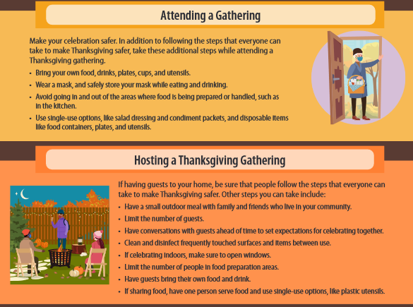

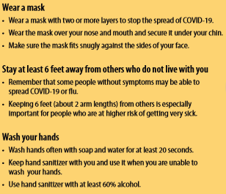

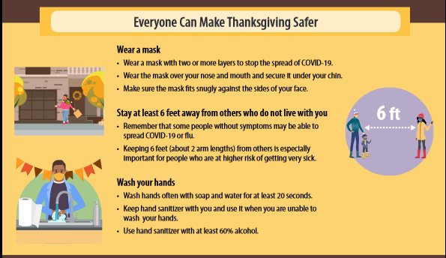

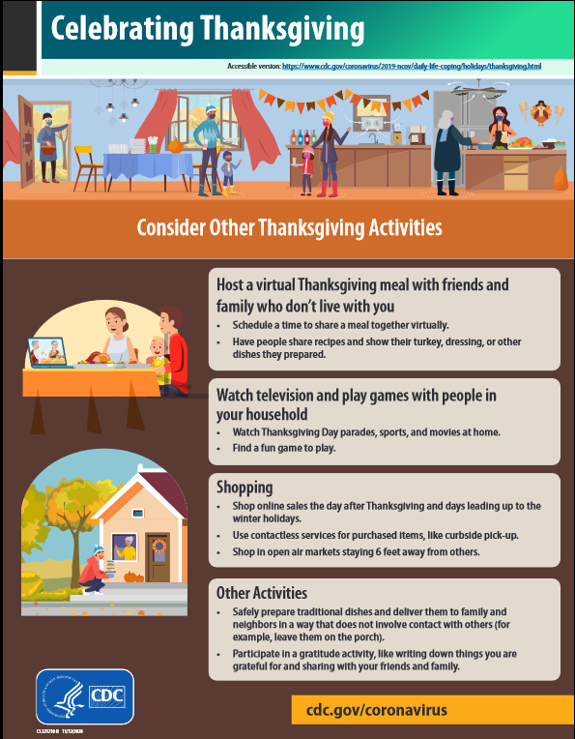

unity**strength**respect**united**steelworkers