**Presidents letter**

Brothers and Sisters of Local 1440, I hope everyone at UPI has had a chance to review and make their decision on the Summary that was put out on the proposed contract. Today is the Vote day so make sure you all get out to vote because every vote counts no matter how you decide to vote make sure your voice is heard by the ballot you fill out. Once voting is closed and all of the ballots are counted the results will be posed for everyone to see.

I would like to congratulate Danny Hicks of Bishop Wisecarver for becoming the new Guide of Local 1440. Danny is the first person from Bishop to hold an office other than the Grievance position. Thank you for stepping up and I have full confidence you will do a great job at you new position.

**In Solidarity, Ben Salazar**

**Summary Contract Votes will be Collected and counted at closing of voting today at 4pm.**

**We will then post the results by flier, Email, and on the**

**union website (uswlocals.org/local-1440).**

**We like to thank the hard work of our Tellers.**

**No matter the Vote, Every Vote Counts!**

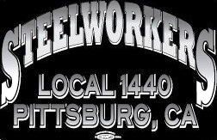

Union Meetings Are Held the 2nd Thursday Of Every Month. Our Next Meeting Will Be

**Thurs, Feb. 13th**

5:30PM At the Union Hall

677 Cumberland Street

Pittsburg, CA 94565

Phone: 925-432-7396

Submit your email to receive Contract updates

and other important notifications.

* Go to: **uswlocals.org/local-1440**
* Click on the link “stay updated”
* Fill out the form and Submit.



**Retirements:**

**Halgas, William - 33 Years**

**MTM-Rolling Maintenance/Rolling Division**

**8/22/1986 - 1/30/2020**

**Tyson, Daron R. - 32 Years**

**MTE-Electrical Maintenance/Sheet Division**

**04/13/1987 - 1-24-2020**

**We Want to Wish our Union Brothers A prosper and Healthy Retirement**

**UPI CARDINAL RULE #2**

**#2. NEVER OPERATE A CRANE UNLESS AUTHORIZED.**

**DO NOT BOARD UNLESS AUTHORIZED AND ACKNOWLEDGED BY A CRANE OPERATOR.**

**\*MUST BE AUTHORIZED BY A SUPERVISOR.**

* **Hand signals are to be continuous during crane operation.**
* **Always remain in a visible, direct line of sight, with the crane operator.**
* **All signals are from the crane operator’s perspective, not the signal person (for example, when the signal person is facing the operator a motion to move the load using his right arm will see the crane operator moving the load to his left)**
* **If the signal is not understood, unclear, or cannot be seen by the crane operator they must stop all crane movement**

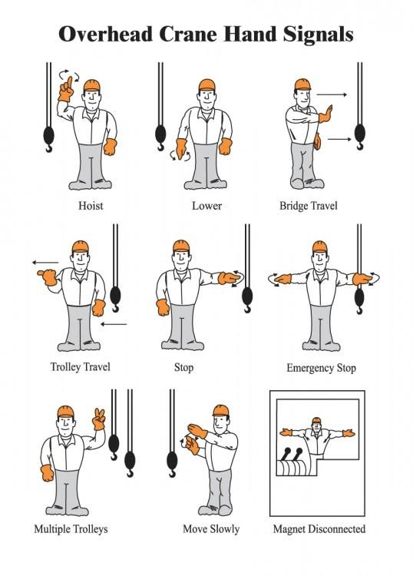

**Wage Safety**

**Columbia Athletic Association**

Presents

**Cosmic Bowling and Laser Tag**



**At**

**DELTA BOWL**

**3300 Delta Fair Blvd., Antioch**

**On**

**Saturday, February 1, 2020**

**6:00 p.m. to 8:00 p.m.**

**Sign up today for this family friendly event!!**

**(Space is limited)**

**$10.00 Per Person** **Includes:**

**Rental Shoes**

**Pizza/Soda**

**Private Party Room**

**One Round of Laser Tag**

**Glow-In-The-Dark Bowling**

**Strobe and Dance Lights**

**To sign up, please contact:**

**Michelle Miller at 6068 (mmiller@ussposco.com)**

**or**

**Alicia Torres at 6040 (atorres@ussposco.com)**

**USW Cares**

**2019 Jefferson award winners**

-District 12

**Xochitl Cobarruvias, Local 675**

Cobarruvias has tirelessly helped the communities of Carson and South Los Angeles, Calif., by collecting money, food, and school supplies for those in need. She started a popular monthly food bank that has delivered more than 1 0,000 bags of groceries to the needy. Because of her, 2,000 families were able to have a Thanksgiving meal and 5 00 children received backpacks with school supplies last year. She raised over $7,500 for families involved in area sports programs to buy uniforms and cover fees

unity****strength****respect****united****steelworkers