Brothers and Sisters of 1440 I wanted to give an update on how the Union is dealing with Covid-19, As you should have seen the Union meetings have been canceled as we are following the direction of the Contra Costa County orders and the recommendation of the International to hold all of the meetings until the county has eased up on the social distancing order.

I understand that we have some members that do not agree with the face coverings but we must wear them unless you have a note from your doctor’s office.  We all need to take care of our own safety and the safety of others during this time with following the precautions the county has put into place with social distancing and face coverings. If you are within 6 feet of another person and or walking through a high traffic area your face covering must be worn properly.

Arcelormittal steel just had a press release last weekend that they have had 21 people test positive for Covid-19 at one of their facilities. UPI, Bishop Wisecarver and RTW have been very lucky to not have had a flood of cases and knock on steel we stay this way. The Union hopes we can get back to normal operation in the very near future so we can continue on with business as usual,

Any questions, concerns or comments please email me at salazar.usw1440@gmail.com

**Presidents letter**

**Hot off the press News!**

Our Local email Blast can be signed up for by

* Go to: **uswlocals.org/local-1440**
* Click on the link “stay updated”
* Fill out the form and Submit.

**Retirements:**

**Kobierski, Wanda – 33 Years**

**Utility Tec - Tin Warehouse 5/21/1987 - 07/31/2020**

**Lucero, Milton – 47 Years**

**OP Tech- PLTCM Rolling 7/9/1973 - 08/17/2020**

**Young, John – 13 years**

**Op tech 1 – Utilities 8/7/2006 – 7/21/2020**

**We Want to Wish our Union Member A prosper and Healthy Retirement**



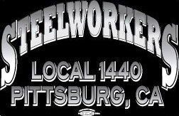

**Wage Safety**

**Taking Safety Home:**  We practice safety at work in all that we do; do we do the same at home? Safety at home is equally as important at work; the biggest difference is we have our families watching us. Are you willing to teach your kids, nieces, nephews or your kids’ friends the unsafe way to do a task? Probably not!

One item we might overlook at home is the proper disposal of items that are potentially hazardous (especially if mixed) to us or detrimental for the environment. What do you do with chemicals at home? Electronics? Batteries? How do you dispose of these items at home? At work we have a place to dispose of everything, blue bins for oily debris, 55-gallon cans for used aerosol cans, bins for used fluorescent lights, old paint cans even a used oil disposal site.

If you live in Eastern Contra Costa County, we have the Delta Diablo sanitation district (www.deltadiablo.org and look under services) that can help us teach our families to be safe and responsible for the environment. They have a household hazardous waste drop off point that we can use at no cost. You can check their web site to see what they take, their address and phone number.

Remember safety does not only apply at work! We must practice safety at home as well. Let’s set a new standard for safety at home and teach our families and friends why safety at home is great!

Union Meetings Are Held the 2nd Thursday Of Every Month. Our Next Meeting Will Be

**Aug. 13th unless postponed**

5:30PM At the Union Hall

677 Cumberland Street

Pittsburg, CA 94565

Phone: 925-432-7396

**We all have that restaurant that makes you hungry when you hear its name…**

We are talking about the “little hole in the wall, mom and pops place”. That one spot you grew up on, or frequent often,

and with the current situation of the country these businesses are dwindling. The Covid19 is a hard hit on everyone but some of the best might not stay afloat during the storm, with a little work you can help keep them above water.

Buy Gift cards, Order Take-out, shop locally online, take virtual fitness classes, contribute to/or start a GoFundMe campaign.

Also share! Get the word out, social media is a easy and great way to help. Enjoying that food or the great quality of a service? Share it and let others know and tag the company!

**Editors Corner**

# Vice President Brown Testifies on Behalf of USW Members on Lessons from COVID-19 on Trade, Manufacturing and Critical Supply Chains. Vice President **Roxanne Brown** today testified on behalf of USW members before the U.S. House Committee on Ways and Means' Trade Subcommittee. The hearing was on “Trade, Manufacturing, and Critical Supply Chains: Lessons from COVID-19.”

# While a pandemic rages USW works to help in any way possible, from retooling workforces to preparing for the aftermath.

# Below are some snippets of the speech given this is only a small fraction of the speech, the entire speech is located on our website for your Viewing.

“The United Steelworkers is the largest industrial union in North America.  We represent workers in a vast array of industries and sectors, and we are uniquely positioned to discuss the themes of Trade, Manufacturing, and Critical Supply Chains.  From mining to metals, from auto parts to transportation, from paper to education, from health care to pharmaceuticals, our members are employed across the entire economy.” –

“While there is much to debate and improve upon, it is helpful to share a few stories about how the American labor movement has stood up to protect Americans during this pandemic. Below are just a few examples of workers and manufacturers coming together to produce goods that are part of a supply chain saving lives today because of this interconnectivity”

* “More than 40 members of USW Local 721 at Braskem America participated in a “live-in” at their production facility in Neal, West Virginia, beginning in March of this year, rotating in 12-hour shifts to create homopolymers for nonwovens, which are used to make N95 face masks and medical gowns.
* Local union members at Qure Medical in Rock Hill, South Carolina produce critical products such as rubber stoppers for syringes; seals for medicine bottles; and valves, tubes and other components for intravenous drug-delivery systems and catheters. The demand for these products doubled as the COVID-19 crisis increased and our members of Local 1811-01 stepped in, working safely to produce these small, but vital components.
* At the beginning of the COVID-19 crisis one USW employer, American Roots, which traditionally produced blankets and clothing items faced 75 percent layoffs. The company retooled to produce face masks and face shields, and it was USW-represented workers at the nearby Twin Rivers paper mill who helped produce the medical wrap paper needed for the PPE face masks built by American Roots. This effort led to a recall of all their laid-off workers and the company hiring 75 more employees. “

“These examples represent a small fraction of what an interconnected and localized manufacturing economy can do when facing an international crisis. The question for lawmakers is how we foster and build upon existing manufacturing networks to increase our resilience during times of challenge, while increasing broad economic prosperity.”

“The COVID-19 crisis and the effective collapse of Personal Protective Equipment (PPE) availability is a failure that should not have happened, and as a country we all share blame in letting this deferred maintenance in manufacturing undermine our supply chain resilience, and weaken our stock piles to the point where healthcare professionals are forced to reuse equipment increasing the likelihood of transmission or higher rates of sickness. While this crisis is a visceral life and death reality of what a collapsed supply chain can mean, our country faces a larger deficit in manufacturing that could undermine our national security, lead to additional shortages of vital goods, and leave our nation exposed to a global marketplace with a strengthened Chinese economy.”

“We also have to recognize the value of manufacturing as a bread and butter issue for American workers. Manufacturing workers earn 13 percent more in hourly compensation (wages and benefits) than comparable workers in the rest of the private sector.  Manufacturing firms are far more likely than non-manufacturing firms to introduce new products and new production or business processes. A 2008 Business R&D and Innovation Survey by the National Science Foundation found that 22 percent of manufacturing companies, but only 8 percent of non-manufacturing companies, introduced a new or significantly improved good or service between 2006 and 2008.  Finally, improving our manufacturing footprint in a coordinated fashion will reduce our trade deficit. Since 1975, the United States has accumulated a total trade debt of $8 trillion, and the cumulative trade debt could grow to $18 trillion in the next 10 years. The trade deficit matters, as it reduces national income and employment in both the short and long-term.”

**“Improve Our Domestic Pharmaceutical Supply Chain**

Of growing importance is where our medicines are produced, and for good reason. The United States pays the highest prices in the world for its medicines (many of which derive from NIH-funded research) while U.S. pharmaceutical companies are often taxed at quite low, effective rates. Meanwhile, we’ve been losing our pharmaceutical supply chain. Last year, the United States imported $128 billion in pharmaceuticals.”

“USW members who manufacture pharmaceuticals know too well their jobs’ dependence on foreign supply chains. According to the FDA, only 28 percent of active pharmaceutical ingredient (API) manufacturing facilities are located in the U.S. Meanwhile, Chinese pharmaceutical companies supply more than 90 percent of U.S. antibiotics. Increasing our pharmaceutical manufacturing will also lead to high road jobs as the 294,250 American workers employed in pharmaceutical and medicine manufacturing currently have a median income of $74,890.”

**“Deploy Trade Policy Tools and Properly Fund Agencies to Create New Markets for U.S.-made Critical Products** For example, in the Department of Commerce’s Fiscal Year (FY) 2021 budget, the International Trade Administration (ITA) proposed a budget of $474,407,000 in discretionary appropriations, a decrease of $35,843,000 from the FY 2020 appropriation. This is the agency that investigates our country’s trade enforcement cases, and without adequate resources manufacturing workers will continue to face dumped and subsidized goods. ITA is also the agency that has programs like the Market Development Cooperator Program (MDCP), which, on average, generates $357 in exports for every $1 invested.”

**“Address Industrial Overcapacity** A looming threat that will face our country and the globe as we emerge from this pandemic is existing foreign industrial overcapacity in many base commodities. Other countries led by China have recognized the power of manufacturing, and in an effort to capture market share and dominate industries, such as steel, aluminum, tires, and paper, have created international market distortions, which have required trade enforcement actions to ensure private domestic industry is not swamped by a flood of imports.”

unity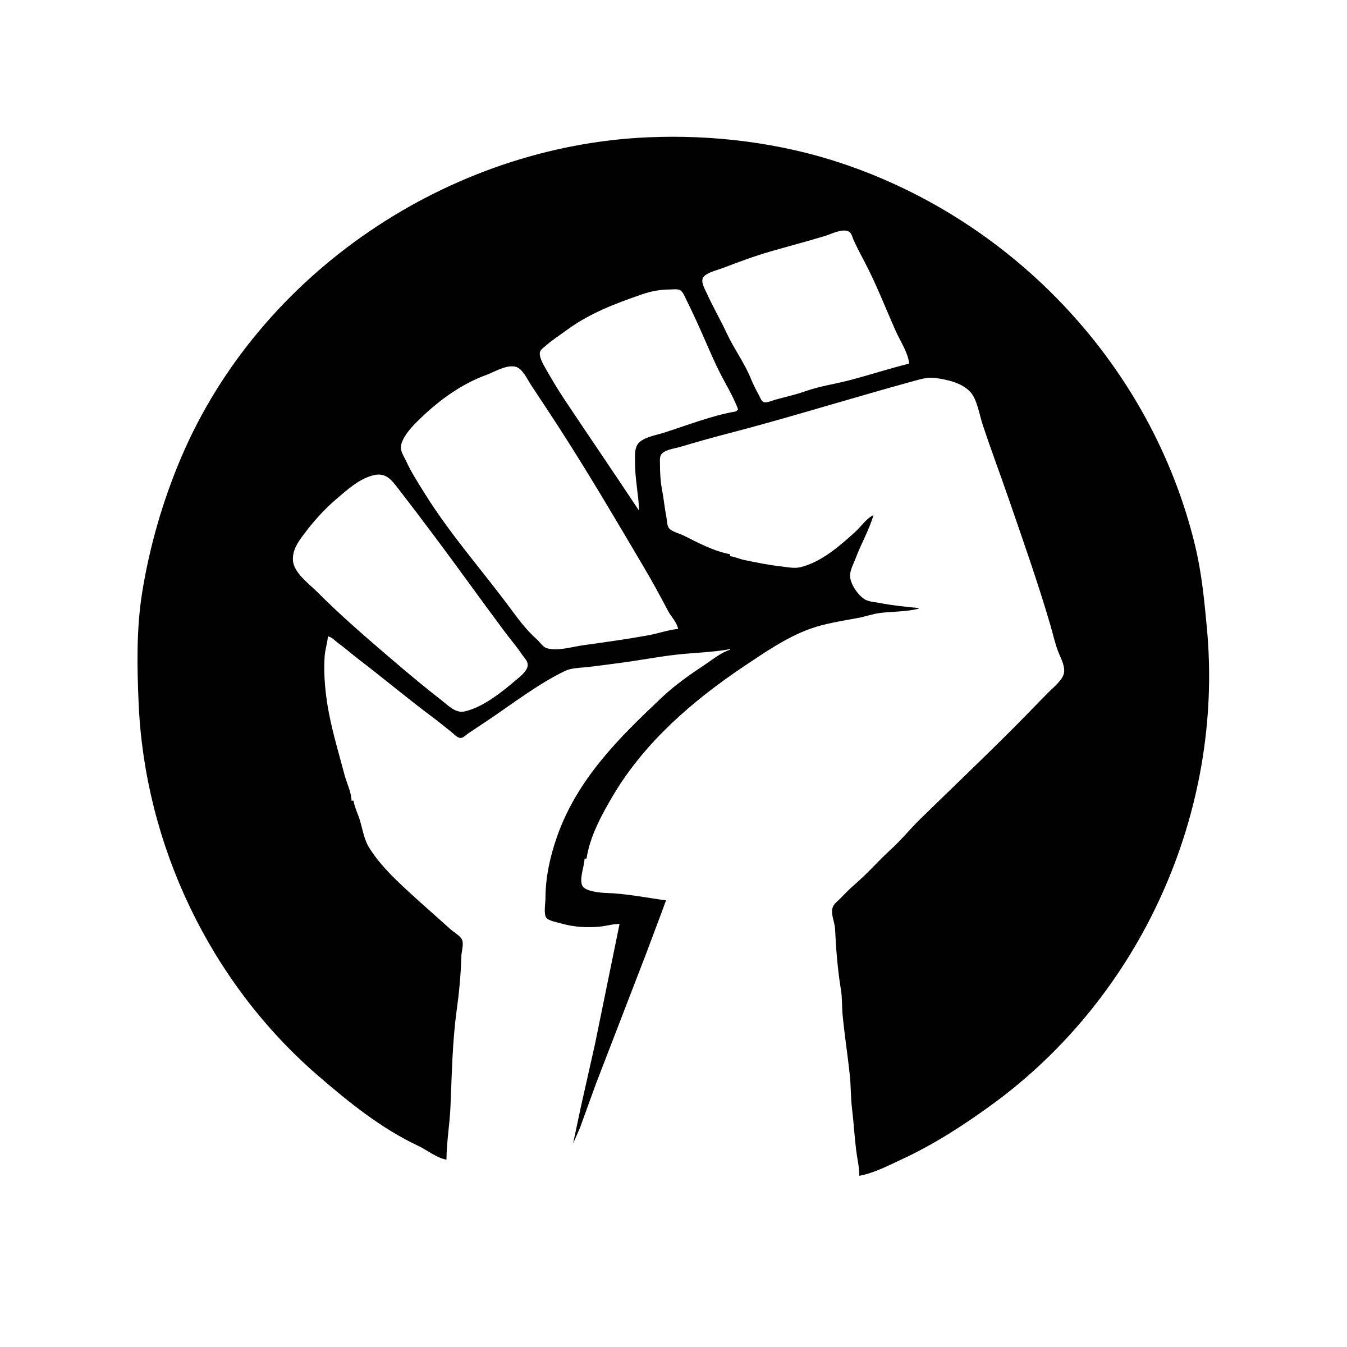strength****respect****united****steelworkers