**Presidents letter**



Submit your email to receive Contract updates and other important notifications.

* Go to: **uswlocals.org/local-1440**
* Click on the link “stay updated”
* Fill out the form and Submit.

Simple as that!

You will receive updates of the contract by email.

Take a look around the website.

Last Thursday we received great news! The U.S Department of Commerce made their final ruling and have decided to cut the countervailing duty on Posco’s hot-rolled steel to .55% from 41.57%. Now we have to wait until this Thursday (6/20) to get the final ruling for the Anti-Dumping.

We received the scores back on the MTM assessment and have posted them on the Local 1440 web site. If you would like to see how well you did, log onto the web page and you can look up your sign in number or there is a QR link on the next page.

This week we are starting negotiation with UPI. Updates will be posted on our web site and Facebook. If you want to know what is going on during our talks sign up for the contract updates and you will receive an email when they are posted. We have done a lot of preparation for this and I feel we are well prepared.

The last month in safety has been a tough one as I’m sure you have seen. There is a lot going on this time of year with summer, Vacation, Kids out of school, the heat wave along with other things. We all need to remember to take the time and make sure we are keeping ourselves and others safe. Everyone wants to go home to our families like we arrived to work. I hope you and your family’s enjoy safety day. Local 1440 will be there at a booth selling T-shirts and will have a call to action card for the safe working conditions in Hospitals and medical field that I hope you can fill out to give our support. Ever worker deserves safe working conditions no matter what job they are doing.

Have a safe day!

In Solidarity,

Ben Salazar

Salazar.usw1440@gmail.com

**Stay Connected!**

It is more important than ever to stay updated with recent items, both union and non-union. We suggest many ways to stay connected, Our Primary way is to join in on the monthly meetings at the hall. This is the best way because it gives information out and allows instant feedback and questions.

Other secondary ways include this Rank and Filer,

Facebook at **www.facebook.com/usw1440** which is updated by our local.

The local union website at the following **http://uswlocals.org/local-1440** this website is newly founded by the local and will be updated to fit our own shape and need.

**\*Columbia Athletic Association\***

**Experience your favorite Theme Parks, Shows, Attractions and Events at a Discounted Price.**

**To see a full list contact:**

**Michelle Miller (6068), or Alicia Torres (6040).**

**Your ICD Money is waiting for you!**

Online @ www.icdupi.com

Widen your horizons, learn a new skill!

Hands on workshops, Online Classes, Tuition assistance all at your fingertips.

**From your contracting out Chairmen**

Do you see a contractor doing a membership job? That member may not even know they should be getting that work!

**If you see something, say something!**

But who do you get ahold of?

Please contact Luke Adkins for any questions and concerns.

**Adkins.usw1440@gmail.com**

**Retirements:**

**Wiseman, Barbara - 42 Years**

**Op. Tech I CC2/Sheet Division**

**06/19/77 - 06/28/19**

**We Want to Wish our Union Member A prosper and Healthy Retirement**

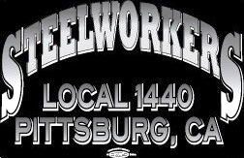

Union Meetings Are Held the 2nd Thursday Of Every Month. Our Next Meeting Will Be

**Thurs, July 11th**

5:30PM At the Union Hall

677 Cumberland Street

Pittsburg, CA 94565

Phone: 925-432-7396

We are also collecting used jeans to support the Veterans Project there is a barrel at the main gate. (please no stains)

Thank you for your continued support.

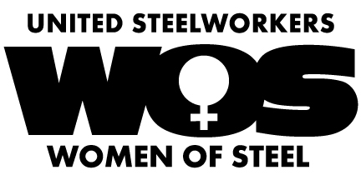

**CALIFORNIA STATE FAIR. JULY 12TH-JULY 28TH**

**CAL EXPO, SACRAMENTO**

**USW LOCAL 1440 & LOCAL 5**

**WOMEN OF STEEL**

RAFFLE FOR OUR VETERANS PROJECT

**$1.00 - 1 RAFFLE TICKET**

**$5.00 - 7 RAFFLE TICKETS**

**YOUR FUN PACK WOULD INCLUDE:**

**4 STATE FAIR TICKETS**

**4 RIDE/MONORAIL RIDE TICKETS**

**1 PARKING PASS**

**$49.99 VALUE**

*NEED NOT BE PRESENT TO WIN*

DRAWING JULY 2ND

DURING THE LOCAL 5 REGULAR MEETING

USW LOCAL 5 - 1333 PINE ST, MARTINEZ- 6:30 PM

**For ticket purchase**

**Please contact Steph DeLaRosa / x6306**

**Or Download here!**



**The test results are in!**

MTM’s took a written test recently.

Covering the skills needed to preform

industrial mechanical work.

We have posted the results on

our website in an easy to read

PDF version attachment.

**Upcoming Meetings**

# Retiree Helps Fellow Nuclear Workers Apply for Cancer Assistance in Oregon

Garry Steffy typically starts his day with a cup of coffee and a quick look through the newspaper for obituaries of people who once worked for ATI Specialty Alloys and Components in the small town of Millersburg near Albany, Ore. This daily routine is more than a retiree’s curiosity. Steffy has made a mission of searching for USW members and former co-workers who qualify for a special government compensation program for those exposed to radiation while working on the U.S. nuclear weapons program. “We have a rare opportunity here to assist our brothers and sisters,” Steffy, a District 12 coordinator for the Steelworkers Organization of Active Retirees (SOAR), said during an interview also attended by Albany Chapter 12-7 Trustee  Eugene Jack. “Me and Jack, we’re old Steelworkers. We’ll go to the end to help.”

Over several years, Steffy and his fellow SOAR members led the charge in spreading the word about the compensation program. They have helped hundreds of ATI retirees; employees and their families receive more than $42 million in federal compensation and medical benefits. And that number will most likely continue to grow. “I love when people get the money,” said Steffy, who started Oregon’s first SOAR chapter after he retired from ATI in 2010 with 36 years of service. “But I hate that they had to suffer to get it.”

Congress passed the Energy Employees Occupational Illness Compensation Act (EEOICPA) in 2000 to provide benefits to nuclear weapons project employees who were sickened by exposure to radiation and/or other toxic substances. Survivors of deceased workers were also eligible to file claims. The metals refinery in Millersburg can trace its ownership to a company that began operations in the 1900s as the Wah Chang Trading Co. In 1956, the Atomic Energy Commission, now the U.S. Department of Energy (DOE), contracted with Wah Chang to develop and produce a high-purity zirconium for the U.S. Navy.   Zirconium is used to contain radioactive uranium used in nuclear reactors and on the Navy’s nuclear submarines and aircraft carriers. The facility, now owned by Pittsburgh-based ATI, a global manufacturer of technically advanced specialty materials, remains a major refiner of zirconium as well as other exotic metals such as hafnium, niobium, tantalum, and vanadium. It is one of the largest producers of rare earth metals and alloys in the United States.

## ****Melting uranium****

In the 1970s, Wah Chang was contracted by Union Carbide Corp. to melt uranium-bearing material from the Y-12 National Security Complex in Oak Ridge, Tenn. Union Carbide operated Y-12 from 1947 to 1984 for the Atomic Energy Commission and the DOE. A special furnace called S-6 was used to melt the material, which was pressed into billets or ingots and shipped back to Oak Ridge. It later became clear that not all of the radioactive material was removed. The facility in Millersburg, which claimed a population of 1,329 in the 2010 census, was designated an atomic weapons facility in 2011 under the EEOICA and awarded special cohort status. Under that status, workers who contracted one of 22 listed cancers were eligible to file a claim and receive compensation of $150,000 and medical benefits for life. If you did not qualify in that part of the program, employees could be compensated under a more complicated “dose reconstruction” formula that considers age, gender and areas worked. Claims would be approved if the numbers added up to a 50 percent probability that an employee may have contracted a cancer from radiation while employed there.

Steffy learned in 2011 from a newspaper notice that he and co-workers at ATI Specialty Alloys, widely known to locals by its previous name Wah Chang, had been exposed to radioactive materials. Unbeknownst to Steffy, the family of former Wah Chang employee Roy Backer in 2010 petitioned the National Institute of Occupational Safety and Health (NIOSH) to declare workers at the plant eligible for benefits under EEOICPA. Most workers at the Millersburg plant were never told about the uranium that was processed there or warned to take extra precautions, according to Steffy and a series of reports in the Corvallis Gazette-Times by Bennett Hall. “We always heard rumors about radiation,” said Steffy, who for 25 years operated the S-6 electron beam melting furnace that processed the uranium from Y-12.

## ****Notification letters****

After Steffy heard about the program, he started to campaign to let ATI employees know. In the early stages, the company would not publicize the compensation program, but would confirm employment when requested by the program administrators. Steffy also contacted local attorneys and funeral homes all around Oregon to look for ATI retirees who may have contracted cancer. SOAR several times sent hundreds of notification letters to retirees. “I’ve gone to nursing homes to visit people who were literally on their last dime in their checking and savings accounts and they get this check,” he said. “It takes the pressure off them and their family.”

In March 2016, as ATI was ending a six-month lockout of 2,200 USW members nationwide, the Millersburg facility stopped responding to requests by the Department of Labor for employment records of former employees seeking the radiation compensation. In refusing to verify employment, the company caused claims for compensation to be denied. That prompted Steffy to contact U.S. Rep. Peter DeFazio and U.S. Senators Jeff Merkley and Ron Wyden, all of Oregon.

After political pressure from the Oregon delegation, ATI Millersburg resumed employment verification in October 2016, and, for the first time, sent out letters to all current and retired employees informing them of the federal compensation program. “In most cases, this was the only proof of a worker actually being employed at the plant,” Steffy said. “If these men had not stepped up to the plate and helped out, frankly I do not know where we would be now.”

The three politicians were publicly thanked for their intervention in late 2018 in a letter signed by International President Leo W. Gerard and District 12 Director Robert LaVenture. “Garry should be given credit for his hard work and desire to bring justice to this issue,” LaVenture said. “Garry, like many of our SOAR members, never quit wanting to help others after he retired.”

Steffy credits SOAR, the late International President Lynn Williams, who created the retiree program, and his local union President Jim Kilborn, for asking him to get involved with the organization. The ordeal is not yet over. Steffy is asking the government to expand the program to include additional areas of the refinery, a request that could help others who worked around the S-6 furnace. Some areas, he said, were never decontaminated. “We had a ventilation system that would suck the dust out, and in the winter, it would blow hot air on you. They never cleaned that out and through the years people would breathe in this radioactive dust,” he said. Steffy is seeking records from NIOSH and the Center for Disease Control that he believes might make the case. But unable to pay an estimated $5,000 records fee, he has sought help from Sen. Merkley to get the documents. If he prevails, Steffy thinks another group of employees and retirees may receive enough additional credits or points to qualify for an additional $25 million in assistance. In the meantime, Steffy continues looking out for other retirees and, occasionally, himself. He undergoes a physical twice a year with the knowledge that he could be diagnosed with cancer.

“I know I’ll get it because I worked around the stuff,” he said. “I’m just waiting until the doctor tells me I have it.”

How invested are **YOU** in **Your** union?

Join, Campaign, Contribute, be part of the movement that you want to see.

**You can be the key to change!**





**Information & Resources**

**The Heat is Upon Us!**

Proper hydration is key, what we drink today will affect us tomorrow! Water is the best drink for us. Alcohol, sugar, caffeine all are diuretic and take water to from our bodies to properly dispose of them. This means they can and will dehydrate us! For every can of beer, shot of hard alcohol, glass of wine cup of coffee or tea and can of soda, we must drink one extra bottle water to counteract the effects of these drinks. With energy drinks the rule of thumb is three extra waters to one energy drink.  This “extra” water is on top of the recommended 101 ounces of water a day for men and at least 74 ounces of water a day for women. This is according to the Institute of Medicine (IOM).

If we see a coworker showing signs and symptoms of heat illness, we must call 6200. Heat exhaustion and heat stroke are medical conditions that must be addressed immediately. The signs and symptoms of heat exhaustion are: confusion, excessive sweating, hot flushed skin, high pulse rate, headache, fatigue and weakness/dizziness. Signs and symptoms of heat stroke are: stopped sweating, altered mental status with confusion or agitation, possible progression to loss of consciousness and seizure and can it can be fatal.

If you suspect a heat illness, get the employee to a cool area, remove any excess clothing, have then sip, NOT DRINK, room temp water, call 6200 and get a wet towel on the back of their neck. Heat illness affect the elderly and children faster as well as affecting our pets!

In Solidarity;

Your Wage Safety Reps and Fire Chief.

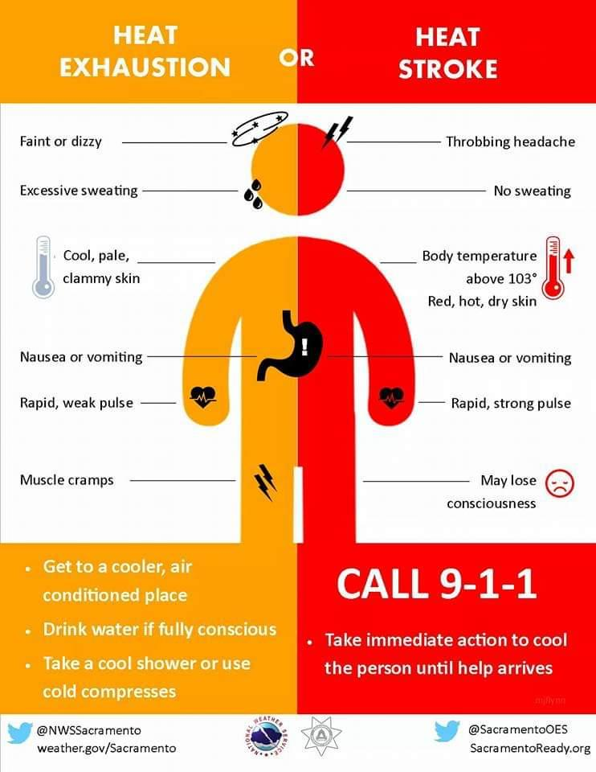

Is there something you like to see in the Rank and Filer?

Do you have a question or comment on The Issues?

Get Ahold of us at Douglas.usw1440@gmail.com

“To improve is to change; to be perfect is to change often.” – Winston Churchill



**Safety with Summer**

**Local 1440 T-Shirts!**

Long /Short Sleeve

Available for $20

at the union hall.

Cash only.

unity****strength****respect****united****steelworkers

**Grievance Committee**

**Buzz Enea Jr - Grievance Chairman**

**Lashon Craig - Rolling Grievance**

**Steph DeLaRosa - M & I Grievance**

**Joe Perez - Sheet Mill Grievance**

**Mike Miller - Tin Mill Grievance**

**Phil Blasingame - Wage & Rate**

**Luke Adkins - Contracting Out**

**Ramil Jose - Bishop Wisecarver**

**Dan Evans - Roll Technology West**