**Presidents letter**

Brothers and Sisters of 1440, we are still waiting on an answer from the parent companies of what their hot band agreement will be for next year so we can get back to the negotiations table and get our contract finished. Last we have heard is the parent companies are continuing to talk and hope to have a finished agreement soon.

There has been some concern with the WARREN notice letter going out, the slowdown on the Tin side, and our coil field being empty. What is going on? I have not heard of any talks about Layoffs at this time, but I can see them using the vacation shutdown during the holidays.

On the business side of USSPOSCO, everything is Business as usual. The Sheet Mill side is going strong holding at a 4-crew level with orders still coming in to complete the end of the year and looks to keep 4 crews into 2020. The Tin side is slowing down as it typically does during the 4th quarter as our customers are not pulling up orders like last year due to a rumor of lower Tin prices in 2020. Hot bands are slowly arriving with the Railroad Company having a shortage of Coil cars. As of last week, there are over 200 cars on the way here with more coming.

Next week Steve Berendsen and Myself will be attending the Rapid Response conference and have set up some appointments with trade commission officials and politicians. We will be talking about the trade issues and laws that have been put into place and how they are affecting us. We are hoping they will understand what we are dealing with in California and can hopefully help us out to get POSCO back at our dock.

I Hope everyone has a Great and Safe Halloween. With the holidays here make sure you keep your mind on working safe as we have had a lot of incidents, injuries, and Near Misses in 2019 so left make the rest of the year injury free. Any questions, comments, or complaints you can reach me at Salazar.usw1440@gmail.com.

**In Solidarity**

**Ben Salazar.**



Submit your email to receive Contract updates

and other important notifications.

* Go to: **uswlocals.org/local-1440**
* Click on the link “stay updated”
* Fill out the form and Submit.

**Attention USW Local 1440 Members**

**Local 1440 has a vacancy for our Guide position. If you would like to be considered for this position please send written correspondence to**

**Steve Berendsen at the local union hall by 3:00pm Wednesday November 13th**

**677 Cumberland St. Pittsburg CA**

**Usw1440@gmail.com**

**Phone-925-432-7396**

**Fax-925-432-9736**

**In Solidarity, United Steelworkers Local Union NO. 1440**





**CAA HALLOWEEN COSTUME PARTY**

**BUFFET DINNER, DANCING,**

**& RAFFLE PRIZES**

**Saturday OCTOBER 26th**

**7pm to Midnight**

**At LONETREE GOLF COURSE**

**$25 (Includes dinner and drink tkt.)**

**For Tickets Call**

**ext. 6068 or 6040**

**Safety at Work and Home**

What you do at home,

Would you do that at work?

What we do at work, we need

 to do at home.

Take safety home with you!

The previous statement and question are two important reminders. These were made by a union brother who was involved in a life changing incident at home. He thought he was doing everything right, but a serious incident happened that affected him and his family. The question he asked is very important as we all have taken short cuts at home at one time or another but not so much at work. Why is that? Is it because there is more scrutiny at work? Is it because we are always reminded that safety is first?  We hear ‘STOP and ACT” or “Take 3 Seconds” on a regular basis! Quite possibly! So then, why do not “take it home” with us on a regular basis? That is a question that we can only answer. Our families are important to us and what we do, we do for them; with that in mind, let’s always remember the statement made by our union brother:

“What we do at work, we need to do at home. Take safety home with you!”

**Your Wage Safety Reps**

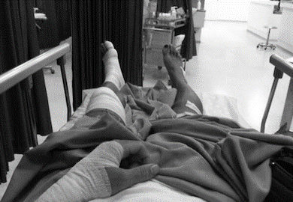

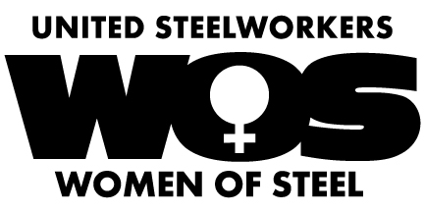

Please join us at the next meeting on

**November 13Th @ 4pm**.

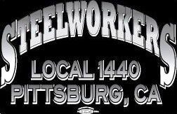

Union Meetings Are Held the 2nd Thursday Of Every Month. Our Next Meeting Will Be

**Thurs, Nov. 14th**

5:30PM At the Union Hall

677 Cumberland Street

Pittsburg, CA 94565

Phone: 925-432-7396

**The union would like to show respect to our lost brothers and sisters.**

Sadly, a brother Joe Stanton pass away on 9/8/2019 at age of 68.

We would like to thank all who showed respect at the celebration of like last weekend on the 20th.

He worked at the mill for 31 years. (1-31-71 thru 1-31-02) including time as the union president.

**A Union is more than a job and coworkers it’s a Family.**

**Retirements:**

**Diffey, Lewis C. – 42 Years**

**Op. Tech 2 ETL/Tin Division 05/16/77 - 10/25/19**

**Neely, Mac – 15 Years**

**Op. Tech 1 ETL/Tin Division 09/13/04 - 10/31/19**

**We Want to Wish Our Brothers a Prosperous and Healthy Retirement.**

**Jackson, Stanley – 29 Years**

**Op. Tech II CC2/Sheet Division 09/10/90 - 02/27/19**

**We Want to Wish our Union Brothers A prosper and Healthy Retirement**

unity****strength****respect****united****steelworkers