**Presidents letter**

Brothers and Sisters, there have been questions asked about some of the things that have been happening lately, so hopefully I can help answer them.

First is the WARN notice that the company has sent out. This notice is required by law to be sent out from the employer if there is a possibility of a layoff of 50 or more employees, the company is required to give employees 60 days advance notice of a pending layoff. Historically, during the 4th quarter of the year when our business slows during the holidays (Thanksgiving, Christmas and New Year), UPI typically will have a vacation shutdown. If an employee still has vacation available UPI will schedule their vacation during those dates. If the employee has no vacation, the employees will be

placed on layoff. This practice has been going on at UPI for many years and is nothing new.

The other topic in question is the contract extension we have agreed to put in place. Negotiations have been going well up to this point, and in my opinion were ahead of schedule. As we got down to the wages and medical the company had asked if we would entertain an extension. The reason for the extension is the company’s lender has in the past had a signed hot bad agreement in place from the parents (USS & POSCO). As of this time they still do not have this agreement. We do know the parent companies are in talks about the hot band supply weekly but we do not have an answer yet on what the agreement will be. I have been in contact with USW Leadership, asking if they have any answers on what is taking place in those talks and from what I am being told is the talks have been productive and they should have a signed agreement in the next few months. The holdup appears to be the Tariffs, and the Countervailing & Anti-Dumping Duties that are currently in place against South Korea. I’m sure you are saying those were just settled and lowered, and yes, you are correct, they were lowered to a level where it will help get us POSCO coils but currently the Steel Market in the United States has been on the decline so the cost of the Hot Bands is down but the Global steel market is up and the prices are very high. With that being said, in order for POSCO to sell us a supply of hot bands they would have to discount the coils so far below the Global market price it could cause them to open themselves up to an Anti-Dumping law suit. Once the parent companies have a signed agreement, we will be back to the table finishing up our contract. UPI has told us everything is business as usual with preparing the business plan for 2020 and beyond.

Hopefully this helps answer the questions that have been going around, if you need more information or have any other questions please contact me at; salazar.usw1440@gmail.com.

I will do my best to answer any other questions you may have.

In Solidarity Ben Salazar



Submit your email to receive Contract updates

and other important notifications.

* Go to: **uswlocals.org/local-1440**
* Click on the link “stay updated”
* Fill out the form and Submit.

**-COMMUNICATION -**

What is communication? How do we use communication in our everyday lives? Is communication important? Why is it important? Can we function without communication? What is communication?

Communication is a noun and is:

1. “the imparting or exchanging of information or news”

2. “means of sending or receiving information, such as telephone line or computers”

How do we use communication in our everyday lives? Is communication important? We use communication by talking to family about vacation plans, talking to coworkers about upcoming orders, ordering food at a restaurant or even saying good night to the kids. Is communication important? **Yes it is!** Without communication we could not do any of the listed examples in the previous sentence! Can we function without communication? The short answer is no! Everything we do in our daily lives involves communication. Without communication we would be lost. When we don’t communicate with each other, mistakes happen, plans are not made, opportunities are missed but worst of all, we could be injured! At work communication is vital to our jobs, from communicating schedule changes, to notifying others of a QA defect, to passing on knowledge of the job at hand to entering a basement or accessing a furnace by ourselves.

Do you ALWAYS know where your coworkers are? Or do you know where you think they are SUPPOSED to be by the task at hand? If we answer this truthfully, the answer is probably “no, not all the time. I think I know where they are SUPPOSED to be”. We area our best line of defense in the work place in regards to QA defects, order changes, injuries or hazards, we just need to COMMUNICATE this with each other to be effective in all we do! Remember, without communication, weather it is verbal, printed or done with hand signals, we cannot do our jobs, make plans for vacation or even say good night to our kids!

**In Solidarity, Your Wage Safety Reps.**

**CAA HALLOWEEN COSTUME PARTY**

**BUFFET DINNER, DANCING,**

**& RAFFLE PRIZES**

**Saturday OCTOBER 26th**

**7pm to Midnight**

**At LONETREE GOLF COURSE**

**$25 (Includes dinner and drink tkt.)**

**For Tickets Call**

**ext. 6068 or 6040**

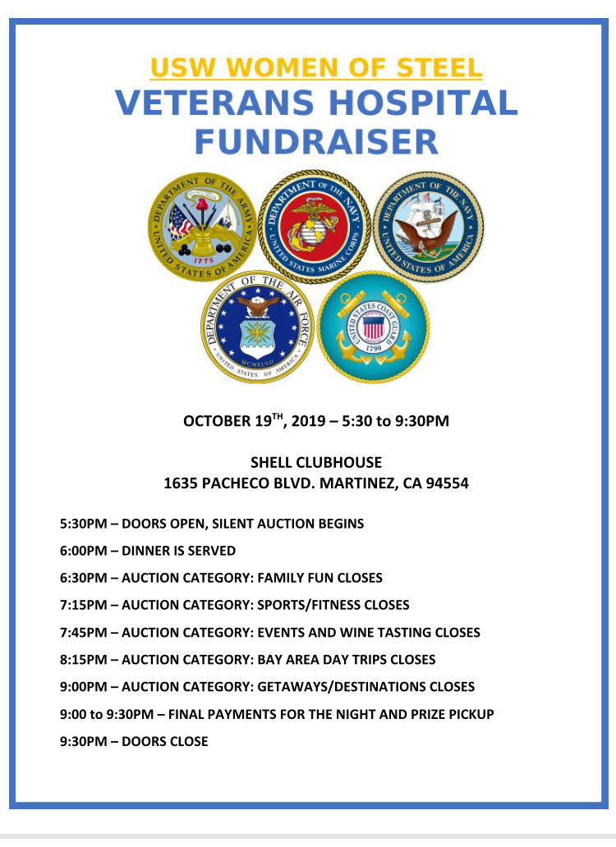 **Please support The Veterans Project Dinner tickets are $35 each and Raffle tickets are 6 for $5 so far there are over 45 raffle prizes to win. There will also be a Silent Auction with All kinds of things to bid on from Family fun, sports, fitness, events, wine tasting, local getaways and a destination getaway.**

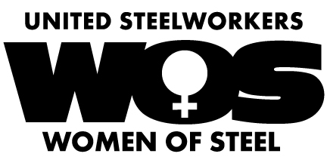

Please join us at the next meeting on

**October 9Th @ 4pm**.

Please see Steph De La Rosa in the Tin Lab if you would like to buy Dinner tickets or Raffle tickets to this awesome cause! If you are unable to attend the dinner and would like to buy raffle tickets or just make a donation that would be greatly appreciated! In Solidarity Steph De La Rosa

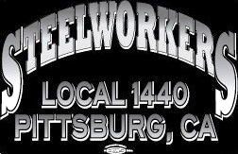

Union Meetings Are Held the 2nd Thursday Of Every Month. Our Next Meeting Will Be

**Thurs, Oct. 10th**

5:30PM At the Union Hall

677 Cumberland Street

Pittsburg, CA 94565

Phone: 925-432-7396

unity****strength****respect****united****steelworkers