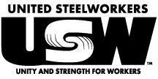
USW LOCAL 2-232

Trial Committee Report Presentation Meeting

SUNDAY, NOVEMBER 24TH, 2019
11:00 a.m.
Milwaukee Area Labor Council Building
633 S. Hawley Road
Yatchak Hall East

Important Business

With the accused found guilty, per the “USW By-Laws for Amalgamated Local Unions” the Trial Committee must present their written report including the recommended discipline for Membership to approve.
*Please note: As this is a Special Membership Meeting, this will be the only business conducted*

