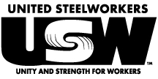
USW LOCAL 2-232

June 2021 MEMBERSHIP
MEETING: BRIGGS UNIT

SUNDAY, JUNE 13TH, 2021
11:00 a.m. – 12:30 p.m.
Milwaukee Area Labor Council Building
633 S. Hawley Road
Yatchak Hall

Important Business

- Reports of Officers, Reps and Committees
- By-Law Changes to be Read (2nd Reading)
- Discussion and action on all other proper business for the meeting

