September 2023 U.S.W. 11-75 Monthly Newsletter Volume 09

* Be Safe, Be on Time.
* Everyone deserves a Respectful Workplace.



**-Hard Core** **Anniversaries-**

Mike Prell - 36 years

Jon Aronson - 33 years

Bill Johnson - 12 years

Ryan Wozniak - 10 years

Patrick Granholm - 9 years

**USW 11-75 has attended the last two Women of Steel WOS events: April 2023 in Cloquet, MN and August 2023 in Billings, MT.**

- - - - - - - - - - - - - - - - - - - -



USW 11-75 QR code for updates.

_________________________

**Found yourself in a pinch? Don’t go in alone- use your:**

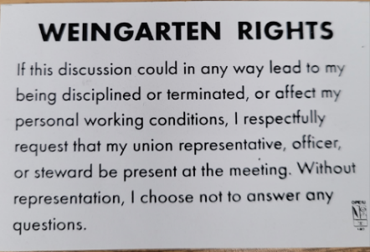

What’s new



**1285 Minnehaha Avenue E. St. Paul, MN. 55106 (651) 774-5943**

[Local 11-75 (uswlocals.org)](https://uswlocals.org/local-11-75) : [District 11 | United Steelworkers (usw.org)](https://www.usw.org/districts/11)

**News-Splash*****_______________________________________________________***

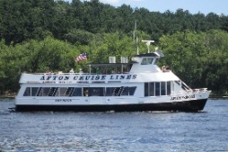 **Summer Event in Hudson**

* MUST BE ON TIME- Friday, September 8th: boarding window begins @ 6pm.

**The Afton Princess is located at:** **98 Walnut Street- Hudson, WI 54022** <https://stcroixrivercruises.com/private-charters/cruise-lines>

* Please monitor your Paystub “Overtime”. Make sure all hours are @ 1.5x pay.
* Stewards are your first point of contact for all Union Inquiries.
* Accessing internal sites from a non-3M device, leaflet ready in October.

**VA has extended the deadline to submit a claim for the PACT Act (links below).**

Powerpoint Presentation (va.gov).

What are the 23 illnesses covered under the PACT Act? (veteranlife.com).

The PACT Act and your VA benefits (Veterans Affairs).

Proud Supporters of:

 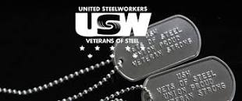  [1]ξ 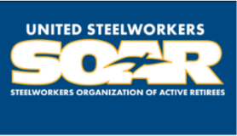

1. ξ **Meetings held monthly (every third Thursday- 3:30 p.m.) at the Union Hall.**