March 2024 U.S.W. 11-75 Monthly Newsletter Volume 15



*Hard Core Anniversaries*

Mark Petzoldt - 34 years

Julie Jurek - 29 years

Tom Plourde - 17 years

** ***A Piece of History***

**Our first U.S.W. 11-75 labor contract with 3M was signed on 02/24/1947. Below is the product range we began supporting 77-Years-Ago**.

________________________________

In a pinch? Don’t go in alone- use your:

WHAT’S NEW



**1285 Minnehaha Avenue E. St. Paul, MN. 55106 (651) 774-5943** [Local 11-75 (uswlocals.org)](https://uswlocals.org/local-11-75) : [District 11 | United Steelworkers (usw.org)](https://www.usw.org/districts/11)

**News-Splash**

* New hire: Please welcome Tony Stacken, Electrician to North Quad.
* Minnesota Safe & Sick effective Jan 1, 2024:
* 80 hours of **Paid** sick leave to frontloaded bucket.
* Can be used by the minute with no waiting period.
* Please confirm product search with 216 Stockroom before pulling from Vendor machines.
* Sick Time tracking via Workday: Notification system now in place when bucket falls to vital 16-hours and critical 8-hours. This will be accessible from home, via a non-3M device, see SOP/Steward.
* Take the time to “Enter Your Time”- Job Security Protection.
* Notify your supervisor when leaving your designated building.
* Please monitor your paystub “Overtime” (all hours @ 1.5x pay).

**USW@Work** is the publication for the workers- visit [www.usw.org](http://www.usw.org) **Rapid Response** is the Steelworkers’ nonpartisan grassroots education, communication, and action program about pending legislation concerning labor and work-related issues. [www.uswrr.org](http://www.uswrr.org).

USW 11-75 QR code for updates.

Proud Supporters of:

 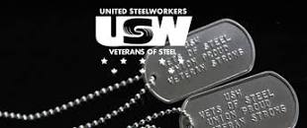 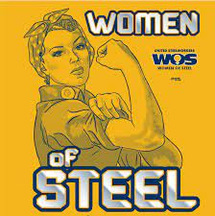 [1]ξ 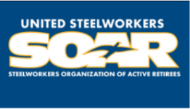

1. ξ **Meetings held monthly (every third Thursday- 3:30 p.m.) at the Union Hall.**