********

*Hard Core Anniversaries*

Bill Johnson - 13 years

Ryan Wozniak - 11 years

Patrick Granholm - 10 years

Rob Miller - 10 years

Found yourself in a pinch?

________________________________________

**A Piece of History**

The first Labor Day holiday was celebrated on Tuesday, September 5, 1882, in New York City, in accordance with the plans of the Central Labor Union. In 1884 the first Monday in September was selected as the holiday, as originally proposed, and the Central Labor Union urged similar organizations in other cities to follow the example of New York and celebrate a "workingmen's holiday" on that date. The idea spread with the growth of labor organizations, and in 1885 Labor Day was celebrated in many industrial centers of the country.

____________________________________

U.S.W. Updates QR Code

WHAT’S NEW

*News-Splash*September 2024 U.S.W. 11-75 Volume 21

* Labor Day! Utilize your benefits wisely to maximize holiday pay.
* Grainger’s Shoe Truck on-site; allowed $225 for one transaction.
* CUT-3-GLOVES are now the minimum requirement for hand safety.
* All Dock Entries: REQUIRE Hi-Visibility Vests beginning July 1st.
* Uniform sizing problems? Use Orange Label in locker room.
* Stewards are your first point of contact for all Union inquiries.
* Monitor your paystub “Overtime” (Company’s not watching for you).
* Take the time to “Enter Your Time”- Job Security Protection.

Overtime cancelled the same day/week is FORFEIT- Failure for our Team!

This is a Union Negotiated Benefit- and the expectation is:

You Scheduled It- You Work It (VOT/ AVOT whole shift).

Canceling overtime the week before- allows those hours back into bucket.

* Frequent offenders earn Union discussion.

Get U.S.W. event info, news alerts and your union card right on your smart phone with our new United Steelworkers app! This free application can be downloaded for Apple users at the App Store (use.to/apple) or for Android users at the Google Play Store (use.to/android).

USW@Work is the publication for the workers- navigate to [www.usw.org](http://www.usw.org)

*Rapid Response* is the Steelworkers’ nonpartisan grassroots education, communication, and action program about pending legislation concerning labor and work-related issues. Please visit [www.uswrr.org](http://www.uswrr.org) for details.

Proud Supporters of:

 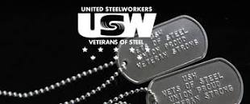  [1]ξ 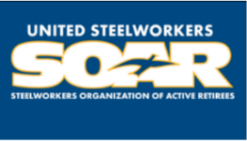

1. **ξ Meetings held monthly (every third Thursday- 3:30 p.m.) at the Union Hall.**