************

*Hard Core Anniversaries*

Cory Barum - 38 years

Scott Larson - 38 years

Carl Lovell - 25 years

Kris Bichner - 12 years

John Singer - 12 years

Aaron Simpson - 12 years

Troy Forcier -10 years

Quincy Nalls -10 years

Scott Persons -10 years

______________________________

**A Piece of History**

International Workers’ Memorial Day: O.S.H.A. created on April 28, 1970. Enforcing working conditions standards and providing training, outreach, education & assistance.

**___________________________**

Largest Industrial Union merge on April 14, 2005. The USWA and the Paper, Allied-Industrial, Chemical and Energy Workers (PACE) International Union merge to form the largest industrial union in North America, the United Steel, Paper and Forestry, Rubber, Manufacturing, Energy, Allied Industrial and Service Workers International Union (USW).

Local 11-75 QR Code

WHAT’S NEW

*News-Splash*April 2025 U.S.W. 11-75 Volume 28

* Change your Outlook (email) “Retention Policy” **before** emails vanish.
* Product Search with 216 Stockroom first- then opt for Vendor machines.
* 110 Survey submissions: #1= Wages, #2= 401K/Pension, #3= Insurance.
* empower.com/3M see our Financial Wellness Summary leaflet.
* Stewards are your primary point of contact for all Union inquiries.
* Please monitor your paystub “Overtime” (all hours @ 1.5x pay).
* Accessing internal sites from a non-3M device: see revised procedure.

Overtime cancelled the same day/week is FORFEIT- Failure for our Team!

This is a Union Negotiated Benefit- and the expectation is:

You Scheduled It- You Work It (VOT/ AVOT whole shift).

Canceling overtime the week before- allows those hours back into bucket.

This must be performed before end of shift- every Thursday.

Found Yourself in a pinch?

Found yourself in a pinch? Do not go in alone- Use Your WEINGARTEN RIGHTS!

Get U.S.W. event info, news alerts and your union card right on your smart phone with our new United Steelworkers app! This free application can be downloaded for Apple users at the App Store (use.to/apple) or for Android users at the Google Play Store (use.to/android).

USW@Work is the publication for the workers- navigate to [www.usw.org](http://www.usw.org)

*Rapid Response* is the Steelworkers’ nonpartisan grassroots education, communication, and action program about pending legislation concerning labor and work-related issues. Please visit [www.uswrr.org](http://www.uswrr.org) for details.

Proud Supporters of:

 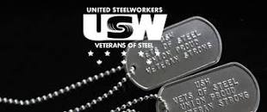 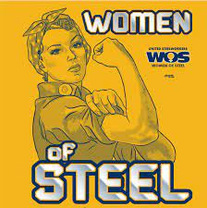 [1]ξ 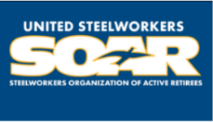

1. **ξ Meetings held monthly (every third Thursday- 3:30 p.m.) at the Union Hall.**