************

*Hard Core Anniversaries*

Greg Mjoen - 15 years

Tony Denzer - 13 years

Tom Schweich - 12 years

Bob Gordon - 11 years

Vicki Zimmerman - 11 years

Jesse Gilpin - 9 years

Sun Lee - 9 years

Tom Alexander - 9 years

Xou Yang - 9 years

______________________________

**A Piece of History**

May Day, also called Workers' Day or International Workers' Day, is the day that commemorates the struggles and gains made by workers and the labour movement. It is observed in many countries on May 1.

Found yourself in a pinch? Do not go in alone- Use Your WEINGARTEN RIGHTS!

Local 11-75 QR Code

WHAT’S NEW

*News-Splash*May 2025 U.S.W. 11-75 Volume 29

* Memorial Day! Utilize your benefits wisely to maximize holiday pay.
* Take the time to “Enter Your Time”- Job Security Protection.
* Grainger’s Shoe Truck on-site monthly. $225 for one transaction.
* Notify your Supervisor when leaving your designated building.
* Change your Outlook (email) “Retention Policy” **before** emails vanish.
* Product Search with 216 Stockroom first- then opt for Vendor machines.
* empower.com/3M see our Financial Wellness Summary leaflet.
* P.E. to P.E. packages & pallets- utilize Stockroom Drivers.
* Please monitor your paystub “Overtime” (all hours @ 1.5x pay).
* Accessing internal sites from a non-3M device: see revised procedure.

Overtime cancelled the same day/week is FORFEIT- Failure for our Team!

This is a Union Negotiated Benefit- and the expectation is:

You Scheduled It- You Work It (VOT/ AVOT whole shift).

Canceling overtime the week before- allows those hours back into bucket.

This must be performed before end of shift- every Thursday.f in a pinch?

Get U.S.W. event info, news alerts and your union card right on your smart phone with our new United Steelworkers app! This free application can be downloaded for Apple users at the App Store (use.to/apple) or for Android users at the Google Play Store (use.to/android).

USW@Work is the publication for the workers- navigate to [www.usw.org](http://www.usw.org)

*Rapid Response* is the Steelworkers’ nonpartisan grassroots education, communication, and action program about pending legislation concerning labor and work-related issues. Please visit [www.uswrr.org](http://www.uswrr.org) for details.

Proud Supporters of:

 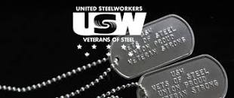  [1]ξ 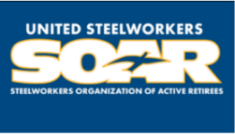

1. **ξ Meetings held monthly (every third Thursday- 3:30 p.m.) at the Union Hall.**