********

*Hard Core Anniversaries*

Graham Pooley - 33 years

Jeff Thomsen - 27 years

Brian Bell - 15 years

Justin Watkins - 13 years

Mike Skoff - 12 years

Jon Ahlgren - 12 years

Bob Schueller - 12 years

Craig Brown - 11 years

Adam Hager - 11 years

Rick Denzer - 10 years

______________________________

**A Piece of History**

John F. Kennedy signs the Equal Pay Act on June 10, 1963. An amendment to the Fair Labor Standards Act, this law is intended to end wage disparities between the sexes.

Found yourself in a pinch? Do not go in alone- Use Your WEINGARTEN RIGHTS!

WHAT’S NEW

*News-Splash*June 2025 U.S.W. 11-75 Volume 30

 Safety First & Sunscreen for a fun filled MN summer!

* Paid Family Medical Leave is effective beginning January 1, 2026.
* Take the time to “Enter Your Time”- Job Security Protection.
* Notify your Supervisor when leaving your designated building.
* Change your Outlook (email) “Retention Policy” **before** emails vanish.
* Product Search with 216 Stockroom first- then opt for Vendor machines.
* empower.com/3M see our Financial Wellness Summary leaflet.
* Please monitor your paystub “Overtime” (all hours @ 1.5x pay).
* Accessing internal sites from a non-3M device: see revised procedure.

Overtime cancelled the same day/week is FORFEIT- Failure for our Team!

This is a Union Negotiated Benefit- and the expectation is:

You Scheduled It- You Work It (VOT/ AVOT whole shift).

Canceling overtime the week before- allows those hours back into bucket.

This must be performed before end of shift- every Thursday.f in

a Local 11-75 QR Code

Get U.S.W. event info, news alerts and your union card right on your smart phone with our new United Steelworkers app! This free application can be downloaded for Apple users at the App Store (use.to/apple) or for Android users at the Google Play Store (use.to/android).

USW@Work is the publication for the workers- navigate to [www.usw.org](http://www.usw.org)

*Rapid Response* is the Steelworkers’ nonpartisan grassroots education, communication, and action program about pending legislation concerning labor and work-related issues. Please visit [www.uswrr.org](http://www.uswrr.org) for details.

Proud Supporters of:

 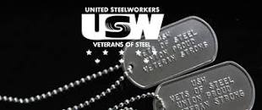 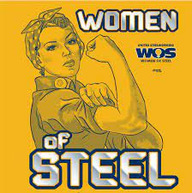 [1]ξ 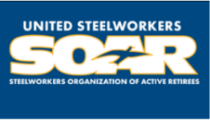

1. **ξ Meetings held monthly (every third Thursday- 3:30 p.m.) at the Union Hall.**