********

*Hard Core Anniversaries*

Tom Trudeau - 35 years

Keith Clemen - 13 years

Ryan Wozniak - 12 years

Chris Schwake - 11 years

Shawn Kelley - 11 years

Rick Reinardy - 11years

Rudy Lamprecht - 11 years

______________________________

**A Piece of History**

Lyndon B. Johnson signs the Civil Rights Act on July 2, 1964. Title VII of this Act outlaw’s workplace discrimination on the basis of race, sex, religion, or national origin (age & disability being added later).

Found yourself in a pinch? Do not go in alone- Use Your WEINGARTEN RIGHTS!

WHAT’S NEW

*News-Splash*July 2025 U.S.W. 11-75 Volume 31

* 4th of July! Utilize your benefits wisely to maximize holiday pay.
* International Nominations selection will be held in Sept. Hall meeting.
* Personify Health- Healthy Living Incentive Discount ends August 31st.
* Paid Family Medical Leave is effective beginning January 1, 2026.
* Take the time to “Enter Your Time”- Job Security Protection.
* empower.com/3M see our Financial Wellness Summary leaflet.
* Please monitor your paystub “Overtime” (all hours @ 1.5x pay).
* Accessing internal sites from a non-3M device: see revised procedure.

Overtime cancelled the same day/week is FORFEIT- Failure for our Team!

This is a Union Negotiated Benefit- and the expectation is:

You Scheduled It- You Work It (VOT/ AVOT whole shift).

Canceling overtime the week before- allows those hours back into bucket.

This must be performed before end of shift- every Thursday. in

a Local 11-75 QR Code

Get U.S.W. event info, news alerts and your union card right on your smart phone with our new United Steelworkers app! This free application can be downloaded for Apple users at the App Store (use.to/apple) or for Android users at the Google Play Store (use.to/android).

USW@Work is the publication for the workers- navigate to [www.usw.org](http://www.usw.org)

*Rapid Response* is the Steelworkers’ nonpartisan grassroots education, communication, and action program about pending legislation concerning labor and work-related issues. Please visit [www.uswrr.org](http://www.uswrr.org) for details.

Proud Supporters of:

 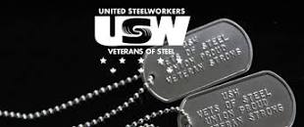 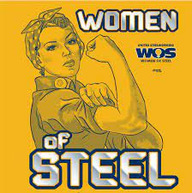 [1]ξ 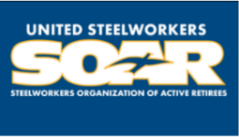

1. **ξ Meetings held monthly (every third Thursday- 3:30 p.m.) at the Union Hall.**