********

*Hard Core Anniversaries*

Bill Wittner - 38 years

Gary Blom - 38 years

Jim Alstrand - 36 years

Scott Carlson - 29 years

Tom Plourde - 18 years

Jim Schwartz - 14 years

Nate Vogt - 12 years

Paul Volkert - 11 years

Scott Taylor - 11 years

Joe Klenner - 10 years

Scott Persons - 10 years

Todd Petschl - 9 years

Klay Huber - 9 years

______________________________

**A Piece of History**

**1925:** African-American workers, segregated into jobs as porters and waiters on the nation’s railroads, organize the Brotherhood of Sleeping Car Porters.

Found yourself in a pinch? Do not go in alone- Use Your WEINGARTEN RIGHTS!

WHAT’S NEW

*News-Splash*August 2025 U.S.W. 11-75 Volume 32

* International Nominations selection will be held @ Sept. Hall meeting.
* Personify- $600 Healthy Living Incentive Discount ends August 31st.
* MN State Fair- District asking for volunteers to occupy USW Booth.
  + Inquire with a Steward and help Build a Stronger Tomorrow.
* Take the time to “Enter Your Time”- Job Security Protection.
* Notify your Supervisor when you leave your designated building.
* empower.com/3M see our Financial Wellness Summary leaflet.
* Please monitor your paystub “Overtime” (all hours @ 1.5x pay).
* Accessing internal sites from a non-3M device: see revised procedure.

Overtime cancelled the same day/week is FORFEIT- Failure for our Team!

This is a Union Negotiated Benefit- and the expectation is:

You Scheduled It- You Work It (VOT/ AVOT whole shift).

Canceling overtime the week before- allows those hours back into bucket.

This must be performed before end of shift- every Thursday. in

a Local 11-75 QR Code

Get U.S.W. event info, news alerts and your union card right on your smart phone with our new United Steelworkers app! This free application can be downloaded for Apple users at the App Store (use.to/apple) or for Android users at the Google Play Store (use.to/android).

USW@Work is the publication for the workers- navigate to [www.usw.org](http://www.usw.org)

*Rapid Response* is the Steelworkers’ nonpartisan grassroots education, communication, and action program about pending legislation concerning labor and work-related issues. Please visit [www.uswrr.org](http://www.uswrr.org) for details.

Proud Supporters of:

 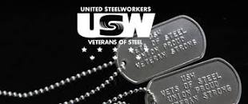 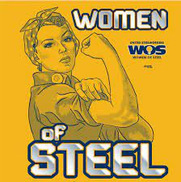 [1]ξ 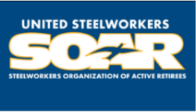

1. **ξ Meetings held monthly (every third Thursday- 3:30 p.m.) at the Union Hall.**