Please welcome: **Wojciech Bury, Millwright a**nd **Michael Gocool, Machinist** to our P.E. Team.

____________________________

********

*Hard Core Anniversaries*

Bill Johnson - 14 years

Ryan Woizniak - 12 years

Patrick Granholm -11 years

Rob Miller - 11 years

___________________________

Found yourself in a pinch? Do not go in alone- Use Your WEINGARTEN RIGHTS!

**A Piece of History**

The first Labor Day holiday was celebrated on Tuesday, September 5, 1882, in New York City, in accordance with the plans of the Central Labor Union. The Central Labor Union held its second Labor Day holiday just a year later, on September 5, 1883. In 1884 the first Monday in September was selected as the holiday, as originally proposed, and the Central Labor Union urged similar organizations in other cities to follow the example of New York and celebrate a "workingmen's holiday" on that date. The idea spread with the growth of labor organizations, and in 1885 Labor Day was celebrated in many industrial centers of the country.

WHAT’S NEW

*News-Splash*September 2025 U.S.W. 11-75 Volume 33

* Happy Labor Day! Utilize benefits wisely to maximize Holiday Pay.
* International Nominations selection will be held @ Sept. Hall meeting.
* Stewards are your first point of contact for all Union inquiries.
* Whirlpool Inside pass? It is real, multi- appliance bundle discounts!
* empower.com/3M see our Financial Wellness Summary leaflet.
* Please monitor your paystub “Overtime” (all hours @ 1.5x pay).
* Accessing internal sites from a non-3M device: see revised procedure.

Overtime cancelled the same day/week is FORFEIT- Failure for our Team!

This is a Union Negotiated Benefit- and the expectation is:

You Scheduled It- You Work It (VOT/ AVOT whole shift).

Canceling overtime the week before- allows those hours back into bucket.

This must be performed before end of shift- every Thursday. in

a Local 11-75 QR Code

Get U.S.W. event info, news alerts and your union card right on your smart phone with our new United Steelworkers app! This free application can be downloaded for Apple users at the App Store (use.to/apple) or for Android users at the Google Play Store (use.to/android).

USW@Work is the publication for the workers- navigate to [www.usw.org](http://www.usw.org)

*Rapid Response* is the Steelworkers’ nonpartisan grassroots education, communication, and action program about pending legislation concerning labor and work-related issues. Please visit [www.uswrr.org](http://www.uswrr.org) for details.

Proud Supporters of:

 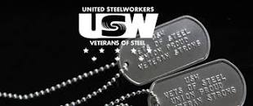 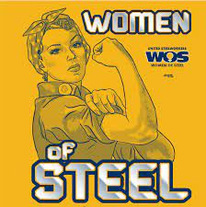 [1]ξ 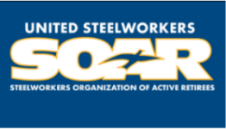

1. **ξ Meetings held monthly (every third Thursday- 3:30 p.m.) at the Union Hall.**