 -New Hire- 
Please welcome: Nick Sirek,
Systems to our P.E. Team.
____________________________

Hard Core Anniversaries

Steve Heilmann - 34 years
Shelly Swanson - 19 years
Chad Seebeck -15 years
Jason Schueller - 14 years
Lori Gilbertson - 9 years
Tony Xiong - 9 years
David Lizarraga Torrez - 9 years
___________________________
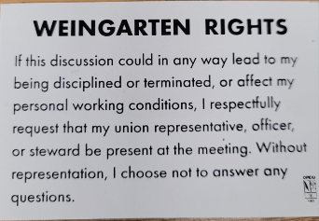
Found yourself in a pinch? Do not go in alone- Use Your WEINGARTEN RIGHTS!

 A Piece of History
Franklin D. Roosevelt signs “Fair Labor Standards Act” on 10/24/1938.
In a sense the culmination of decades of activism, this law mandates an eight-hour day and forty-hour week (with “time-and-a-half” for overtime), the abolition of child labor, and a national minimum wage. It applies to employees whose work relates to interstate commerce. In subsequent decades the law is expanded and improved upon many times, for instance by raising the federal minimum wage and by expanding coverage to some farm workers (in 1966).
WHAT’S NEW

News-Splash October 2025 U.S.W. 11-75 Volume 34
 Stay in well-lit areas and travel in groups for safety.
- C.B.A. Ratification Meeting & Vote @ Green Mill: 10/02/2025 3:30pm.
- Verify your on file address is correct with Financial Secretary Brian Bell.
- Product Search with 216 Stockroom first- then opt for Vendor machines.
- P.E. to P.E. packages & pallets- utilize Stockroom Drivers.
- Stewards are your first point of contact for all Union inquiries.
- empower.com/3M see our Financial Wellness Summary leaflet.
- Please monitor your paystub “Overtime” (all hours @ 1.5x pay).
Overtime cancelled the same day/week is FORFEIT- Failure for our Team!
This is a Union Negotiated Benefit- and the expectation is:
You Scheduled It- You Work It (VOT/ AVOT whole shift).
Canceling overtime the week before- allows those hours back into bucket.
This must be performed before end of shift- every Thursday. in
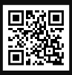 a Local 11-75 QR Code
Get U.S.W. event info, news alerts and your union card right on your smart phone with our new United Steelworkers app! This free application can be downloaded for Apple users at the App Store (use.to/apple) or for Android users at the Google Play Store (use.to/android).

USW@Work is the publication for the workers- navigate to www.usw.org

Rapid Response is the Steelworkers’ nonpartisan grassroots education, communication, and action program about pending legislation concerning labor and work-related issues. Please visit www.uswrr.org for details.
Proud Supporters of:
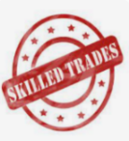 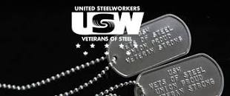 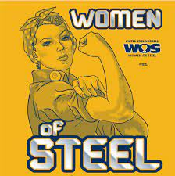 ξ 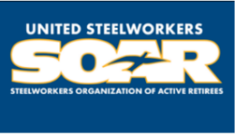

ξ Meetings held monthly (every third Thursday- 3:30 p.m.) at the Union Hall.

