 -New Hires- 
Please welcome: Shane Patten,
Machinist and Emmanuel Steele, Millwright to our Union P.E. Team.
____________________________


Hard Core Anniversaries

Andy Chrissis - 39 years
Rich Nordby - 36 years
Myron Jurek -12 years
Mark Millerbernd - 12 years
Kris Kauppi - 11 years
Dave Rewald - 10 years
Paul Anderson - 10 years
Chad Kohns - 10 years
Neil Millam - 10 years
Steve Portinga - 10 years

Veteran’s Day, Nov. 11th

Thank you for your sacrifices, for your valor, for the things you carry, for protecting us, and for defending our rights. Thank you to all our veterans for your courage, strength and dedication to keeping us safe. You've helped to make this world a better place with your courage, sacrifice, and dedication to our country. No words could ever express how much that means. We live in the greatest country in the world. Thank you for all you're doing to help keep it that way.

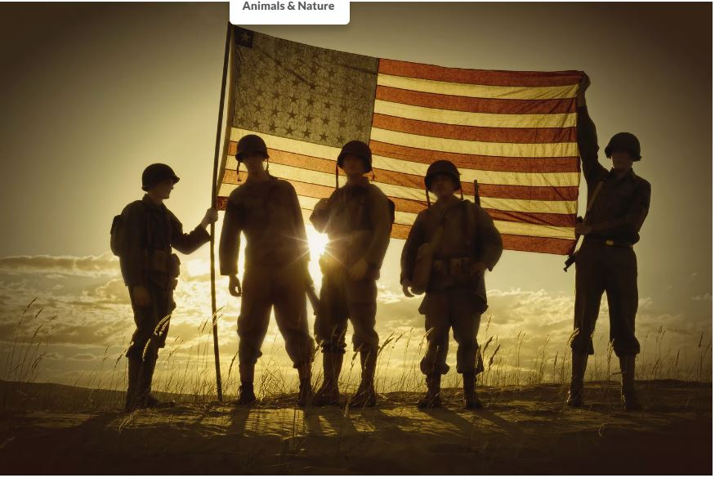
WHAT’S NEW

News-Splash November 2025 U.S.W. 11-75 Volume 35


- Thanksgiving- Utilize your benefits wisely to maximize Holiday Pay.
- Returning Steward appointment accepted by Steve Heilmann @ 205.
- Verify your on file address is correct with Financial Secretary Brian Bell.
- Grainger shoe truck on-site monthly. No slip required
We are allotted $250 for one transaction. Don’t forget insoles.
- Take the time to enter your time. Job security protection.
- empower.com/3M see our Financial Wellness Summary leaflet.
- Please monitor your paystub “Overtime” (all hours @ 1.5x pay).
Overtime cancelled the same day/week is FORFEIT- Failure for our Team!
This is a Union Negotiated Benefit- and the expectation is:
You Scheduled It- You Work It (VOT/ AVOT whole shift).
Canceling overtime the week before- allows those hours back into bucket.
This must be performed before end of shift- every Thursday. in
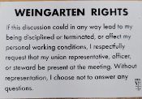 Remember your Weingarten right. 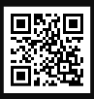 Local 11-75 QR Code
Get U.S.W. event info, news alerts and your union card right on your smart phone with our new United Steelworkers app! This free application can be downloaded for Apple users at the App Store (use.to/apple) or for Android users at the Google Play Store (use.to/android).

USW@Work is the publication for the workers- navigate to www.usw.org

Rapid Response is the Steelworkers’ nonpartisan grassroots education, communication, and action program about pending legislation concerning labor and work-related issues. Please visit www.uswrr.org for details.
Proud Supporters of:
 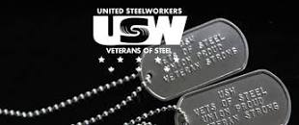 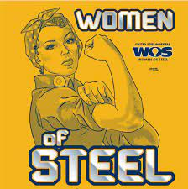 ξ 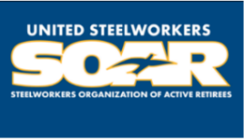

ξ Meetings held monthly (every third Thursday- 3:30 p.m.) at the Union Hall.

