
Hard Core Anniversaries

Joe Nauer - 11 years

 A Piece of History

(Noble) Knight’s of Labor- 1869
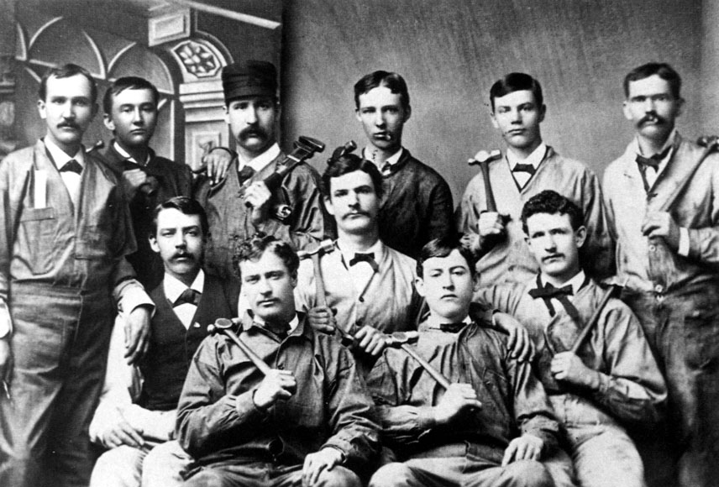
It was founded by Uriah Stephens in Philadelphia, Pennsylvania on December 28, 1869; reaching 28,000 members by 1880. North America's first true international labor organization and the earliest practitioner of "industrial unionism". It originated as a secret organization meant to protect its members from employer retaliations. Secrecy also gave the organization an emotional appeal. Credited with having coined the phrase, "an injury to one is the concern of all". in 1879, the group abandoned its secrecy and mystical trappings and struck the word noble from its title.
Found yourself in a pinch, remember your
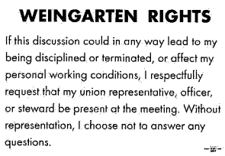
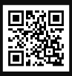 Local 11-75 QR Code
WHAT’S NEW

News-Splash December 2025 U.S.W. 11-75 Volume 36
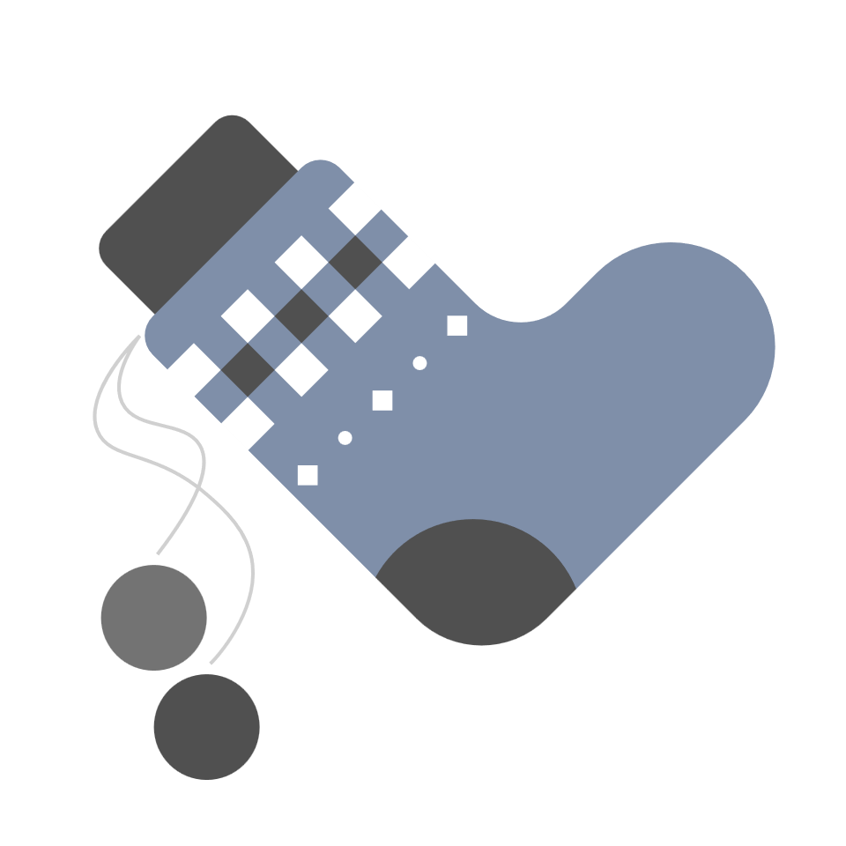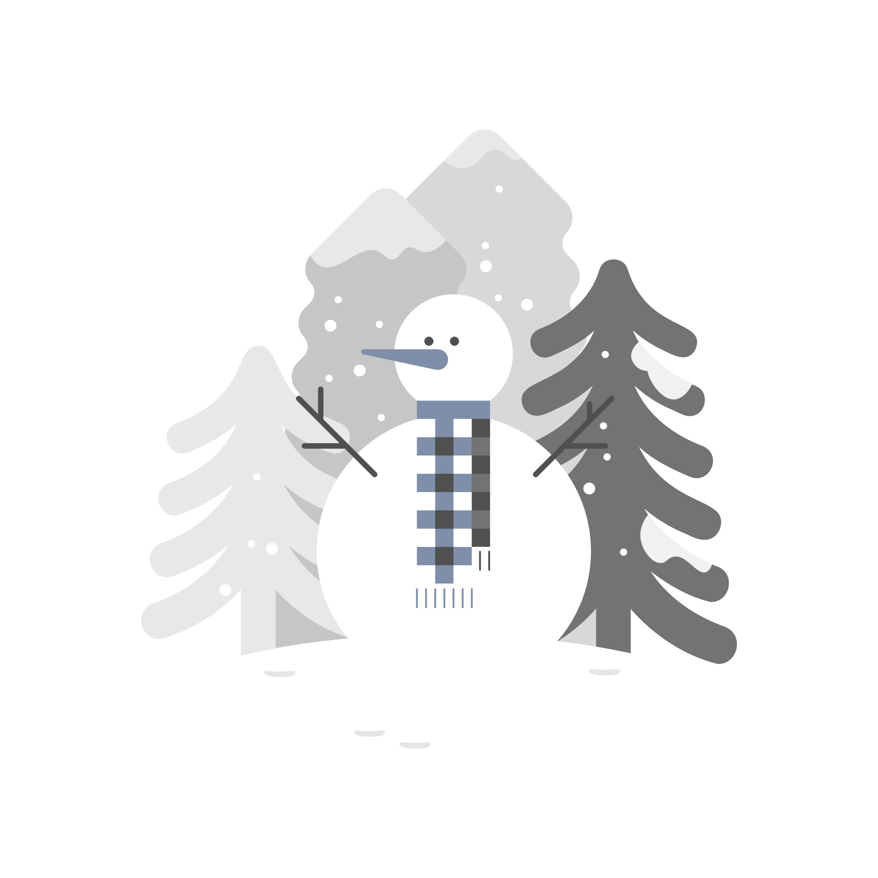
- We are pleased to announce the U.S.W. Executive Board Trustee position has been appointed to and accepted by:
Chris Schwake, 236- Millwright. Welcome aboard Brother Schwake.
- Christmas- Utilize your benefits wisely to maximize Holiday Pay.
- Employee Sale- December 16th, 17th & 18th @ D.C. Warehouse.
- Holiday Potluck Celebration: December 17 @ your dedicated shop.
- Paid Family Medical Leave Act effective Jan 1, 2026 (20-weeks total).
Visit esst.dli@state.mn.us for ESST or paidleave@state.mn.us for FMLA.
- Please DO NOT draft 3M shippers, paying contractors to service.
Utility Drivers exist to handle your parcels and pallets.
- Stewards are your first point of contact for ALL Union inquiries.
- empower.com/3M see our Financial Wellness Summary leaflet.
- Please monitor your paystub “Overtime” (all hours @ 1.5x pay).
Overtime cancelled the same day/week is FORFEIT- Failure for our Team!
This is a Union Negotiated Benefit- and the expectation is:
You Scheduled It- You Work It (VOT/ AVOT whole shift).
Canceling overtime the week before- allows those hours back into bucket.
This must be performed before end of shift- every Thursday.
in
Get U.S.W. event info, news alerts and your union card right on your smart phone with our new United Steelworkers app! This free application can be downloaded for Apple users at the App Store (use.to/apple) or for Android users at the Google Play Store (use.to/android).

USW@Work is the publication for the workers- navigate to www.usw.org

Rapid Response is the Steelworkers’ nonpartisan grassroots education, communication, and action program about pending legislation concerning labor and work-related issues. Please visit www.uswrr.org for details.
Proud Supporters of:
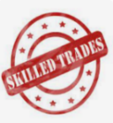 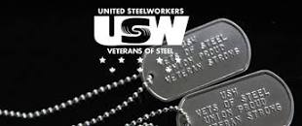 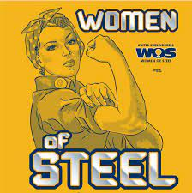 ξ 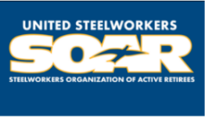

ξ Meetings held monthly (every third Thursday- 3:30 p.m.) at the Union Hall.

