
Hard Core Anniversaries

Marlowe Kokette - 16 years
Dan Sonday - 13 years
Mark MacDonald - 12 years
Chad Jacoway - 12 years
Mike Danich - 12 years
Dan Holmberg - 11 years
Brandon McKean - 11 years
Anthony Caylor-Monzel - 9 years
Marty Rother - 9 years
Tim Asher - 9 years

 A Piece of History
Martin Luther King Jr. Day 1/15
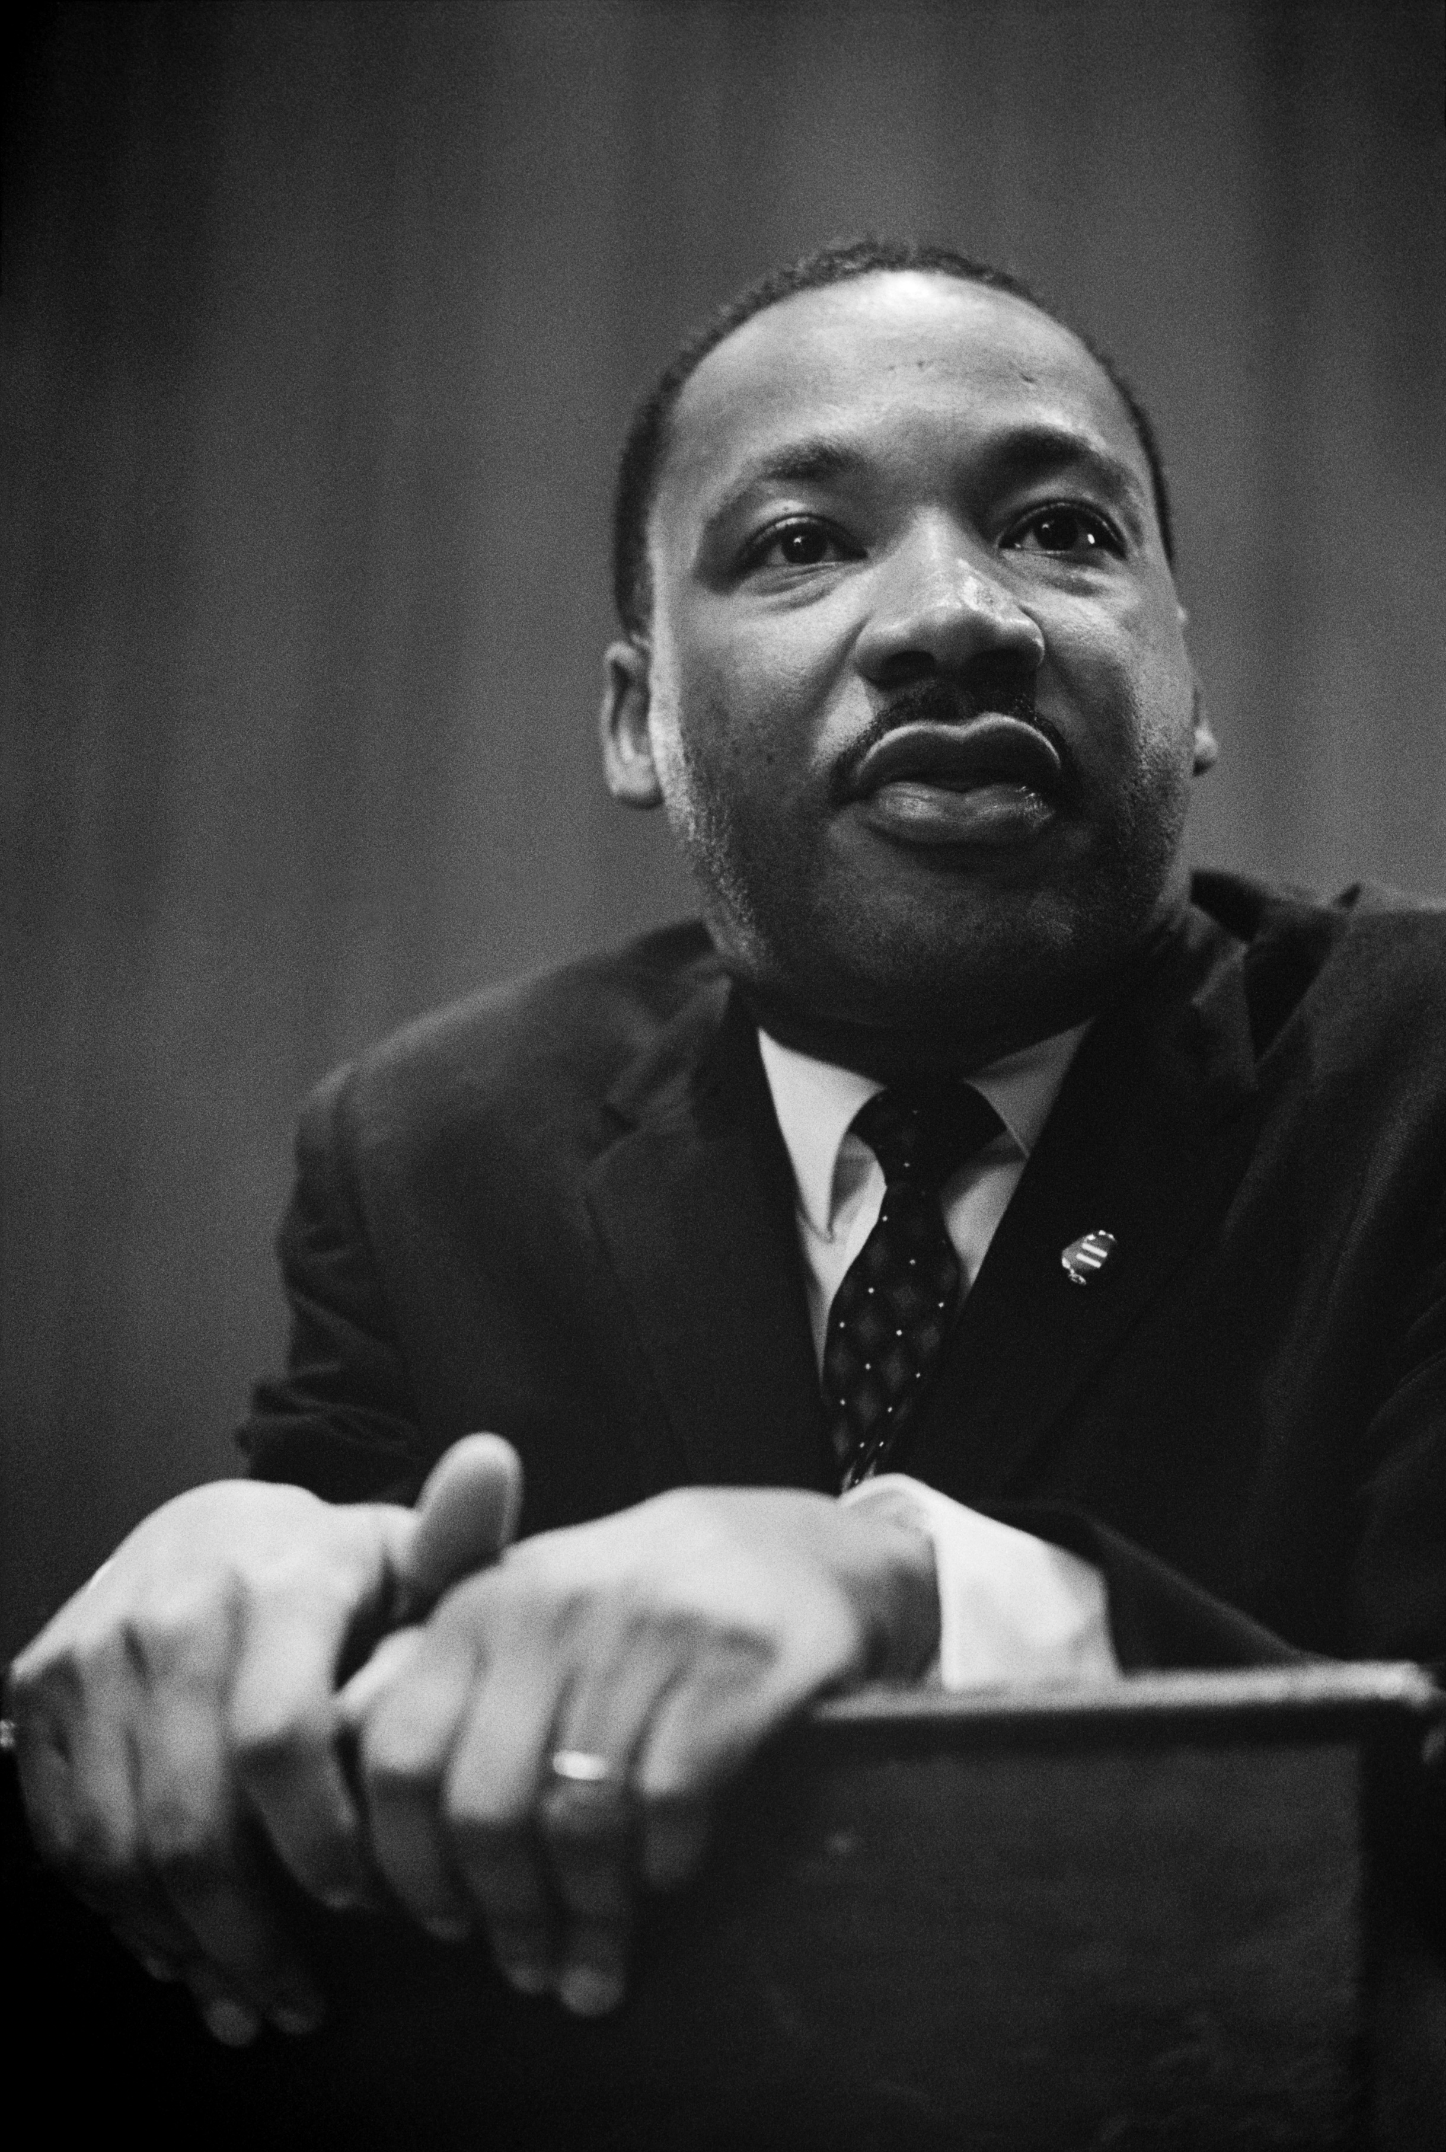
Dr. King was a prominent and prolific writer and public speaker throughout his life. We honor and celebrate his Birthday on January 15th.

Found yourself in a pinch, remember your
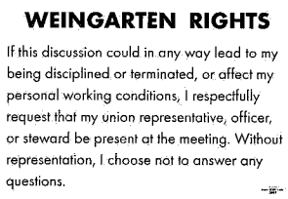

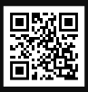 Local 11-75 QR Code

WHAT’S NEW

News-Splash January 2026 U.S.W. 11-75 Volume 37

May the New Year bless you with health and happiness.

- Whirlpool Inside Pass? It is real, multi-appliance bundle discounts!
- Paid Family Medical Leave Act effective Jan 1, 2026 (20-weeks total).
Visit esst.dli@state.mn.us for ESST or paidleave@state.mn.us for FMLA.
- Notify your supervisor when leaving your designated building.
- Hot Gloves are due, please return promptly and look for replacements.
- Grainger Shoe Truck on-site monthly = $250 for one transaction.
- Please monitor your paystub “Overtime” (all hours @ 1.5x pay).
Overtime cancelled the same day/week is FORFEIT- Failure for our Team!
This is a Union Negotiated Benefit- and the expectation is:
You Scheduled It- You Work It (VOT/ AVOT whole shift).
Canceling overtime the week before- allows those hours back into bucket.
This must be performed before end of shift- every Thursday.
in
Get U.S.W. event info, news alerts and your union card right on your smart phone with our new United Steelworkers app! This free application can be downloaded for Apple users at the App Store (use.to/apple) or for Android users at the Google Play Store (use.to/android).

USW@Work is the publication for the workers- navigate to www.usw.org

Rapid Response is the Steelworkers’ nonpartisan grassroots education, communication, and action program about pending legislation concerning labor and work-related issues. Please visit www.uswrr.org for details.
Proud Supporters of:
 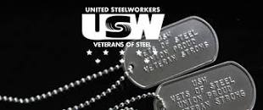  ξ 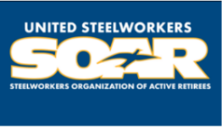

ξ Meetings held monthly (every third Thursday- 3:30 p.m.) at the Union Hall.

