
Hard Core Anniversaries

Tim Ernst - 39 years
Chris Stewart - 11 years
T.J. DeMars - 11 years
Andy Gunderson - 11 years

Found yourself in a pinch, remember your
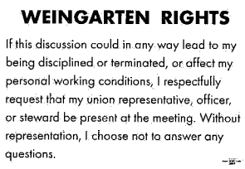
 A Piece of History
Back in 1926

The first television transmission of a Weather Map occurred.

A.A. Milne published “Winnie the Pooh”.

Hirohito became Emperor of Japan.

Bennito Mussolini solidifies power in Italy.

Famous escapologist Harry Houdini dies on Halloween from a ruptured appendix.

Notable Births: Queen Elizabeth II, Marilyn Monroe & Fidel Castro.

The Ford Motor Company adopted a 40- hour, five-day work week.

The Benjamin Franklin Bridge opened, across the Delaware River. It celebrated the 150th anniversary signing of the United States Declaration of Independence. ________________________________________

WHAT’S NEW

News-Splash February 2026 U.S.W. 11-75 Volume 38

Hurrah! Local 11-75 Celebrates our 79th Birthday on February 24 (1947)

- Paid Family Medical Leave Act effective Jan 1, 2026 (20-weeks total).
Visit esst.dli@state.mn.us for ESST or paidleave@state.mn.us for FMLA.
- Stewards are your first point of contact for all Union inquiries.
- Please monitor your paystub “Overtime” (all hours @ 1.5x pay).
Overtime cancelled the same day/week is FORFEIT- Failure for our Team!
This is a Union Negotiated Benefit- and the expectation is:
You Scheduled It- You Work It (VOT/ AVOT whole shift).
Canceling overtime the week before- allows those hours back into bucket.
This must be performed before end of shift- every Thursday.

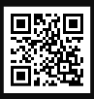 Local 11-75 QR Code
in
Get U.S.W. event info, news alerts and your union card right on your smart phone with our new United Steelworkers app! This free application can be downloaded for Apple users at the App Store (use.to/apple) or for Android users at the Google Play Store (use.to/android).

USW@Work is the publication for the workers- navigate to www.usw.org

Rapid Response is the Steelworkers’ nonpartisan grassroots education, communication, and action program about pending legislation concerning labor and work-related issues. Please visit www.uswrr.org for details.
Proud Supporters of:
   ξ 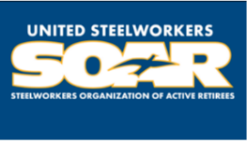

ξ Meetings held monthly (every third Thursday- 3:30 p.m.) at the Union Hall.

