 -New Hires- 
Please welcome: Walker Collison,
HVAC 2nd-Shift Union P.E. Team.
____________________________

Hard Core Anniversaries

Tom Plourde - 19 years
Joe Klenner - 11 years
Isaiah Johnson - 9 years

Found yourself in a pinch, remember your
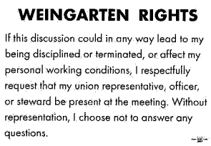
 A Piece of History
Minnesota in 1926
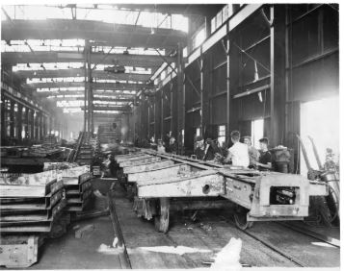
Repair shops of The Great Northern Railway- ¼ of the nation’s miles of freight track passed through Saint Paul. Traffic through Union Depot peaked in the 1920’s with 20K passengers stepping on/off nearly 300 trains each day. Railroads were the most powerful industry in the country at this time.

The Benjamin Franklin Bridge opened, across the Delaware River. It celebrated the 150th anniversary signing of the United States Declaration of Independence. ________________________________________

WHAT’S NEW

News-Splash March 2026 U.S.W. 11-75 Volume 39
- empower.com/3M see our Financial Wellness Summary leaflet. Empower has teamed up with GreenPath Financial Wellness, a highly rated national nonprofit, to provide personalized debt management. Speak with a Financial Wellness Expert 1-844-572-5918 or learn more at www.greenpath.com/empower and mention you are a 3M employee.
- Paid Family Medical Leave effective Jan 1, 2026. Multiple doc’s required.
Visit esst.dli@state.mn.us for ESST or paidleave@state.mn.us for PFML.
- P.E. to P.E. packages & pallets- utilize Stockroom Drivers along with the 20 supported locations using the placard below. 
Overtime cancelled the same day/week is FORFEIT- Failure for our Team!
This is a Union Negotiated Benefit- and the expectation is:
You Scheduled It- You Work It (VOT/ AVOT whole shift).
Canceling overtime the week before- allows those hours back into bucket.
This must be performed before end of shift- every Thursday.
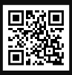 Local 11-75 QR Code
in
Get U.S.W. event info, news alerts and your union card right on your smart phone with our new United Steelworkers app! This free application can be downloaded for Apple users at the App Store (use.to/apple) or for Android users at the Google Play Store (use.to/android).

USW@Work is the publication for the workers- navigate to www.usw.org

Rapid Response is the Steelworkers’ nonpartisan grassroots education, communication, and action program about pending legislation concerning labor and work-related issues. Please visit www.uswrr.org for details.
Proud Supporters of:
 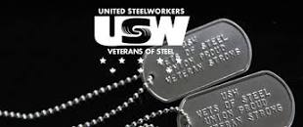 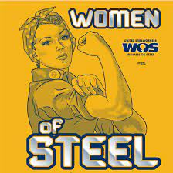 ξ 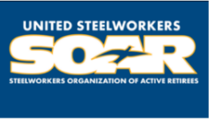

ξ Meetings held monthly (every third Thursday- 3:30 p.m.) at the Union Hall.

