
Hard Core Anniversaries

Cory Barum - 39 years
Carl Lovell - 26 years
Kris Bichner - 13 years
John Singer - 13 years
Aaron Simpson - 13 years
Troy Forcier - 11 years
Quincy Nalls - 11 years
Scott Persons - 11 years

 A Piece of History
International Workers’ Memorial Day:
O.S.H.A. created on April 28, 1970. Enforcing working conditions standards and providing training outreach, education & assistance.
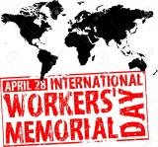
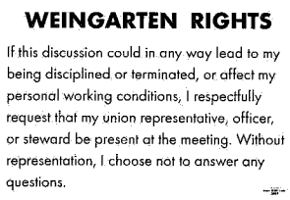
Found yourself in a pinch, remember your:

Largest Industrial Union merge on April 14th, 2005. The USWA and the Paper, Allied-Industrial, Chemical and Energy Workers (PACE) International Union merge to form the largest industrial union in North America, the United Steel, Paper and Forestry, Rubber, Manufacturing, Energy, Allied Industrial and Service Workers International Union (USW).
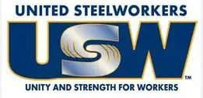
WHAT’S NEW

News-Splash April 2026 U.S.W. 11-75 Volume 40
- empower.com/3M see our Financial Wellness Summary leaflet. Empower has teamed up with GreenPath Financial Wellness, a highly rated national nonprofit, to provide personalized debt management. Speak with a Financial Wellness Expert 1-844-572-5918 or learn more at www.greenpath.com/empower and mention you are a 3M employee.
- Paid Family Medical Leave effective Jan 1, 2026. Multiple doc’s required.
Visit esst.dli@state.mn.us for ESST or paidleave@state.mn.us for PFML.
- Change your Outlook (email) “Retention Policy’ before emails vanish.
- Product Search with 216 Stockroom first- then opt for Vendor machines.
- Stewards are your primary point of contact for all Union inquiries.
- Please monitor your paystub “Overtime” (all hours @ 1.5x pay).
Overtime cancelled the same day/week is FORFEIT- Failure for our Team!
This is a Union Negotiated Benefit- and the expectation is:
You Scheduled It- You Work It (VOT/ AVOT whole shift).
Canceling overtime the week before- allows those hours back into bucket.
This must be performed before end of shift- every Thursday.
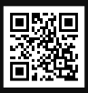 Local 11-75 QR Code
in
Get U.S.W. event info, news alerts and your union card right on your smart phone with our new United Steelworkers app! This free application can be downloaded for Apple users at the App Store (use.to/apple) or for Android users at the Google Play Store (use.to/android).

USW@Work is the publication for the workers- navigate to www.usw.org

Rapid Response is the Steelworkers’ nonpartisan grassroots education, communication, and action program about pending legislation concerning labor and work-related issues. Please visit www.uswrr.org for details.
Proud Supporters of:
 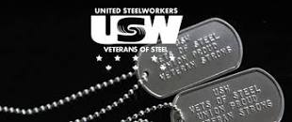 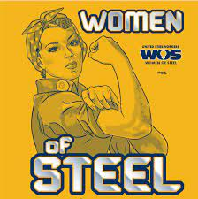 ξ 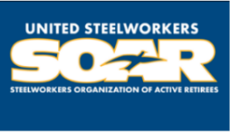

ξ Meetings held monthly (every third Thursday- 3:30 p.m.) at the Union Hall.

