April 2019
Good and Welfare  In Memorial Retirees:  Jess Wright  Walter Ray  Charlie Ralph  Gene Wilkinson  Joe Abanatha  Shirley Greene  Andy Ling  Wilbur Demerest  Dennis Huffman  Kenneth Scott  Merle Neer  Gilbert Leistner  Robert Whitehouse  Ron Pullum  Ron Biggs  Gloria Cobb |  | Stay Informed  Check out our Web site @  USW104.ORG | UNION MEETINGS  3rd Tuesday of every Month  5:05 am  6:10am  7:10am  7:40am  1:15pm  2:15pm  3:15pm  3:40pm
DID YOU KNOW:  EpiPen coverage  There is a market wide shortage of the EpiPen. Lifesaving Ephinephrine auto-injector products at individual stores may be temporarily out of stock. Inventory levels continue to fluctuate and your pharmacy, from time to time, may not have a supply of these products. If you find yourself unable to obtain this product from your In-Network pharmacy and must go Out-of-Network for this, contact me or the union hall. We will need to contact the benefits department at Alcoa to have you reimbursed. They are aware of this situation.  George Barnett |  | Local 104 Communicator  Cheryl Dau  Editor  USW Local 104  3966 Red Brush RD  Newburgh IN 47630  Hall Phone 812-853-3156  Hall Fax 812-853-2973  Email:uswa104@evansville.net  Or Cheryldau@hotmail.com  USW Local 104  P.O. Box 247  Newburgh IN 47629-0247  Http://WWW.USW104.ORG | USW Local 104 SOAR  Mtgs.  2nd Thursday each Month  8:00am @ USW Local 104  Union Hall  3966 Redbrush Rd.  Newburgh, IN
Know Your Contract

Art. IV Section 7 part B. Standard Hourly Rates
A Table of Standard Hourly Rates reflecting a two and one-half percent(2.5%) increase to all job grades effective the first full pay period following ratification (June 9, 2014), is attached hereto at the first rate table listed under Appendix I. Effective June 1, 2015, the standard hourly rates for all job grades will be increased by two and one-half percent(2.5%). Effective June 6, 2016, the standard hourly rates for all job grades will be increased by two and one-half percent(2.5%). Effective June 5, 2017, the standard hourly rates for all job grades will be increased by three percent(3.0%). Effective June 4, 2018, the standard hourly rates for all job grades will be increased by three percent(3.0%).

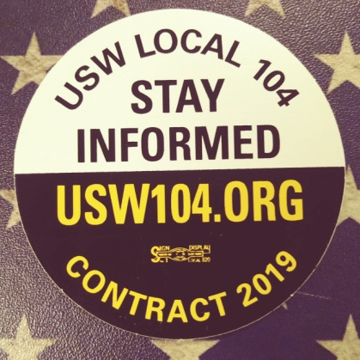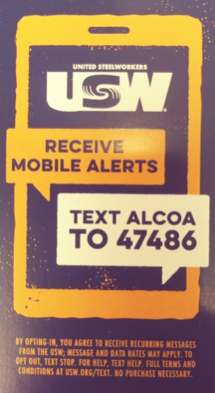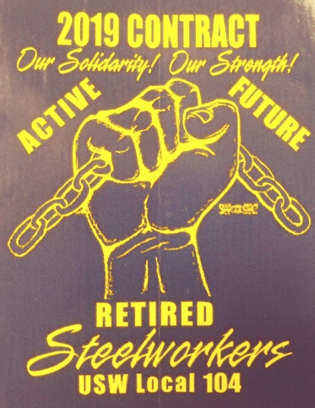

SAVE SOME MONEY EACH PAYCHECK
CONTRACT EXPIRES IN 29 DAYS

T-shirts are here, see your CAT member to get yours.

A Prayer for the Fallen
We remember those we have lost with great fondness.
They gave much to the world; as individuals, family members, friends and work colleagues.
We remember their families in their enormous sadness.
For those who have died at work building a better place for the rest of us.
Those who died while constructing our buildings and expressways, hospitals and schools.
For those who have died young and innocent, victims of avoidable accidents
May we learn from this loss, honour the memory of those lost
And work towards a safer work place for all people
Where the rights and dignity of all workers are upheld above all else
Rev. Ian Lawton

Join us for the Local 104 Worker’s Memorial Celebration
April 26, 2019 at 4:00pm at the union hall

BA report April 2019
Back in July of 2018 the local filed board charges against Alcoa for failing to provide information needed for a grievance investigation. That charge was amended in August after the Union found out that Labor Relations for Warrick Operations told employees they could not discuss the issue with fellow workers or Union officials, both are illegal. The Federal judge Ruled in favor of the Union on all counts. The Company has 28 days to appeal.
First quarter performance pay resulted in a payout of 4.25%, and along with the .41% that was added as a carryover from the 4th quarter of 2018, totaled 4.66%. As you know three new matrix was added for 2019 and they accounted for 1.99% of the first quarter total.
Local issues bargaining began on April 9th, with the Union presenting 16 proposals that were based on member feedback. The Company proposed doing away with all agreements with a sunset clause (agreements that expire at the end of the current contract), including eliminating the current VODAT language and Meal Allowance. The Union feels these are benefits that the membership should continue to enjoy and are bargaining to that extent.
It should not surprise us, but piss us off, that the Company has stated that they will once again spend over 5 million dollars for their BCP. It's a shame how much they are willing to spend to keep from giving the members a dime. That money would be better served going towards a new collective bargaining agreement. REMEMBER : THE COMPANY WILL NOT GIVE YOU ANYTHING, NEVER HAVE NEVER WILL!!!

As we prepare to begin bargaining a new CBA starting on April 29th, keep in mind the many benefits that are worth fighting for. Benefits that all working people should enjoy.
-Wage increases
-Pensions
-Quality affordable healthcare
-A voice in the workplace
-Safe working conditions
-Ability to retire with dignity
-Seniority rights
It's never been easy for working people, never has been and never will be. Regardless of how tough this round of bargaining gets or where it leads us, just remember if we stick together we will succeed and become and even stronger Union because of it. Our Solidarity! Our Strength!

Underhill

