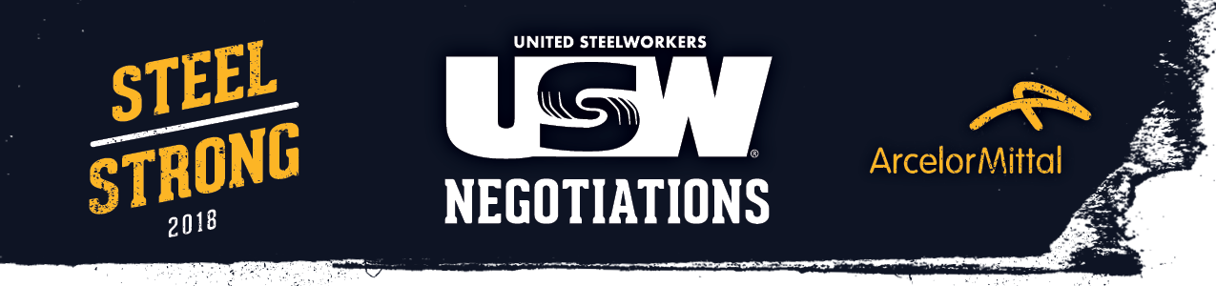

***July 9, 2018 – Update #1***

**SOUND-OFF: ArcelorMittal Seeks Major Concessions  
Despite Market Turnaround**

****Today in Pittsburgh, our 2018 contract negotiations with ArcelorMittal began with our first face-to-face meeting with management. The company provided an overview of its business over the past ten years before presenting its initial proposal, which included major economic and non-economic concessions that would negatively impact every member of the bargaining unit at each USW-represented location:

**Active Health Care** – ArcelorMittal has proposed forcing bargaining unit employees to choose between paying expensive premiums to stay in a lesser PPO plan ($200 per month for a family) or enrolling in a Consumer Driven Health Care plan with $8,000 per year in out-of-pocket costs.

**Retiree Health Care** – Management has proposed doubling monthly health care contributions for retirees.

**Pension Enhancement Payment** – ArcelorMittal has proposed eliminating the $10,000 PEP for employees at former ISG locations.

**Sickness and Accident, Severance, Supplemental Unemployment** – The company has proposed changes to these provisions that provide earnings security for members when they need it most.

**Institute for Career Development** – Management has proposed to end future funding for the ICD.

**Other Issues** – ArcelorMittal is also seeking significant concessions and reductions in areas like incentive pay, vacation pay, family and medical leave, contracting out, seniority, scheduling and others.

The company’s initial proposal fails to include any wage or pension increases or specific commitments to invest in the future of our facilities, even though the market for steel and the products we supply has improved dramatically from the historic lows we experienced in 2015.

Clearly, our committee has much work to do when bargaining resumes in Pittsburgh on Monday, July 16, and as always, we will keep everyone informed as the process continues.