District 10 Women of Steel & Next-Gen are teaming up for some Steelworker activism!
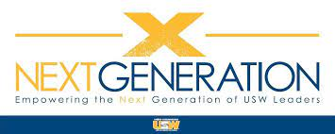
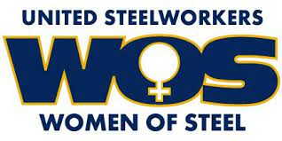

Solidarity Event: Phone Bank!

Friday November 4th:

• Local 719•
(470 Sunbury St, Minersville, PA / 9AM – 4PM.)

Saturday, November 5th:

• Local 719•
(470 Sunbury St, Minersville, PA / 9AM – 2PM.)

• Local 2632 •
(524 Tire Hill Road, Johnstown, PA 9AM – 3PM.)

• Local 10-234 •
(1522 Chichester Avenue & Palmer Drive, Linwood, PA / Noon – Phone Calls are made)

• Local 10-00086 •
(606 Garfield Ave, Lansdale, PA / 10AM – 3PM.)

• Local 1016 •
(106 Broadway Ave, Wheatland, PA 11AM – 2PM)

USW District 10 Women Of Steel & Next-Gen have been working with the PA AFL-CIO to plan and host Phone Banks throughout the District. It will be Steelworkers calling Steelworkers, reminding members of how important it is to get out and vote! Phone lists will be provided. Be a part of the labor movement by joining us at one of the above locations.
If you are unable to attend one of the phone banks, but would still like to participate in making phone calls, please email Charlene Crawford @ ccrawford@usw.org or Colton Smith @ csmith88m@gmail.com.

