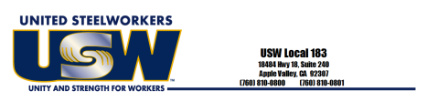LOCAL 183 MEMBER MEETINGS
4TH Thursday of the Month
at 4:00pm
January 27, 2022 July 28, 2022
February 24, 2022 August 25, 2022 March 24, 2022 September 22, 2022 April 28, 2022 October 27, 2022
May 26, 2022 November10, 2022 June 23, 2022 December 08,2022

Coldwell Building
18484 Hwy 18, Suite 240 Apple Valley, CA 92307
(760) 810-0800 FAX (760) 810-0801

