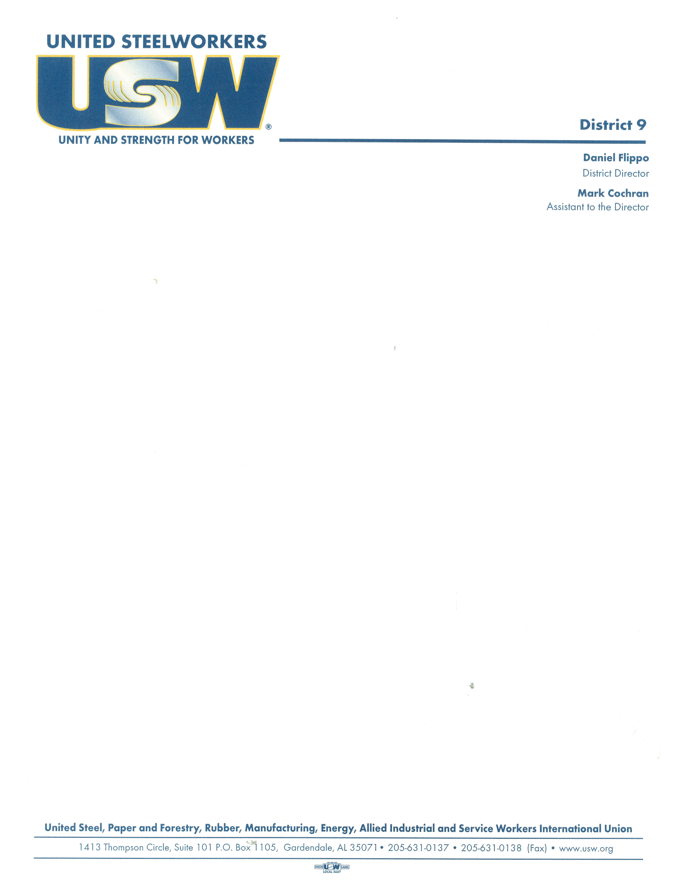

To: District 9 Local Union Members

From: Daniel Flippo, District 9 Director

Date: June 2nd 1:00pm – 3:00 pm

June 4th 5:00pm – 7:00pm

Subject: Covid -19 Webinar Training

Two sessions for Covid- 19 Web Based Training has been scheduled Tuesday, June 2, from 1:00pm -3:00pm. The same training is available also Thursday, June 4, from 5:00p.m. – 7:00p.m.

All local members are invited to log in and attend this informative training. The training will cover the following:

Explain the basics of Covid, assess the risk of workplace exposure, define key steps in worker protection and infection control, and identify methods to prevent and respond to COVID-19 exposure in the workplace.

The USW Health and Safety Department will be conducting these trainings. To take advantage of this opportunity everyone can register and attend here.

<https://uswtmc.org/news/virtual-training-opportunities>

DF

C: Daniel Flippo, Director

Mark Cochran, Assistant to the Director

cid:image001.jpg@01D3548B.F665F260