February 2023 U.S.W. 11-75 Monthly Newsletter Volume 02
Anniversaries to Celebrate.
Tim Ernst- 36 years
Tim Persico- 26 years
Marlowe Kokette- 13 years
Dan Sonday- 10 years
Mark MacDonald- 9 years
Chad Jacoway- 9 years
Joe McDowell- 9 years
Mike Danich- 9 years
____________________________
Found yourself in a pinch?
Don’t go in alone- use your:
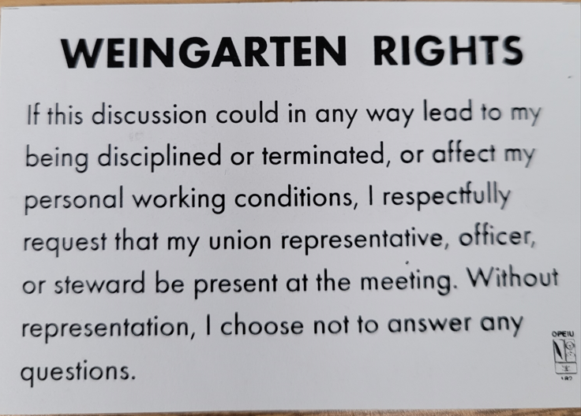

- Meetings are held monthly (every third Thursday- 3:30 p.m.) at the Union Hall.
- Proud Supporter:
What’s new
1285 Minnehaha Avenue E. St. Paul, MN. 55106 (651) 774-5943 Local 11-75 (uswlocals.org) : District 11 | United Steelworkers (usw.org)
News-Splash
Grainger’s Shoe Truck is on Campus monthly. No slip required. We are allotted $225 for one transaction. Don’t forget insoles.
Stay connected with U.S.W. – QR code -.
Simply: Scan, follow the prompts & complete the form. Done!
U.S.W. Website will be updated soon.
* All shipments between U.S.W. / Plant Engineering locations *.
Please DO NOT draft 3M shipper, paying contracting to service.
Your U.S.W. Utility Drivers are available to handle your parcels and shipments. Please contact the 216 Stockroom (651) 733-4188 to schedule or label (R4) and place on your Dock/Site Drop & Pick location. Each locale has the placard below.

