March 2023 U.S.W. 11-75 Monthly Newsletter Volume 03
Our Motto:
- Be Safe
- Be On Time
New Hires-
Please welcome: Tyler Ricci & Jon Fleischhacker- our new Equipment Operators @ 424 warehouse.
_ _ _ _ _ _ _ _ _ _ _ _ _ _ _
Grainger’s Shoe Truck is on-site monthly. No slip required. We are allotted $225 for one transaction.
Don’t forget insoles.
_____________________
Found yourself in a pinch?
Don’t go in alone- use your:
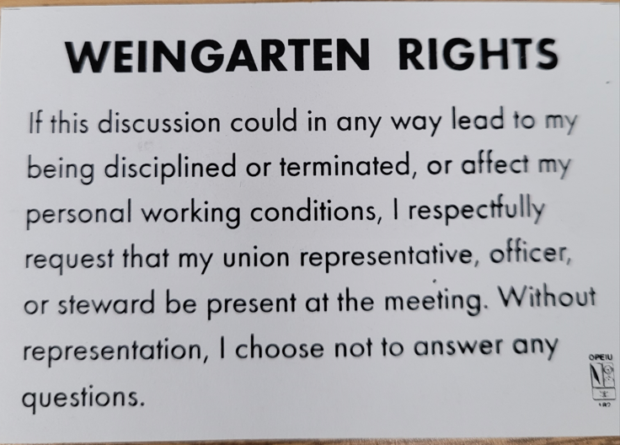

- Meetings are held monthly (every third Thursday- 3:30 p.m.) at the Union Hall.
- Proud Supporter:

What’s new
1285 Minnehaha Avenue E. St. Paul, MN. 55106 (651) 774-5943
Local 11-75 (uswlocals.org) : District 11 | United Steelworkers (usw.org)
News-Splash
- U.S.W Website has been updated- so Check It Out.
- The Covid M.O.U. has been extended to the end of March.
- General Management restructure- reporting to’s have changed.
- P.E. to P.E. packages & pallets- utilize Stockroom Drivers.
- Hot Gloves are almost due, anticipate email & rotate promptly.
Mark Petzoldt- 33 years Don Heaton- 28 years
Julie Jurek- 28 years Tom Plourde- 16 years _______________________________________________________
Stay connected with U.S.W. – QR code -
Simply: Scan, follow the prompts & complete the form. Done!

