May 2023 U.S.W. 11-75 Monthly Newsletter Volume 05
Our Motto…
- Be Safe, Be On Time.
- Everyone deserves a Respectful workplace.
Hard Core Anniversaries…
Dave Schutta - 34 years
Greg Mjoen - 13 years
Tony Denzer - 11 years
Tom Schweich - 10 years
Bob Gordon - 9 years
Vicki Zimmerman - 9 years
>>>>>>>>>>>>>>>>>>>>>>>>>>>>>>>>>>>>>
Summer Event: Boat Cruise to be shared with Cottage Grove USW 11-418. Arrangements are being made for early August/ Member + Guest. ______________________
USW 11-75 QR code.
Found yourself in a pinch? Don’t go in alone- use your:
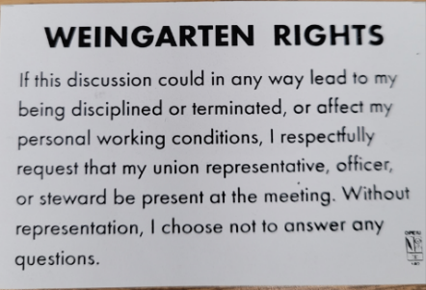
What’s new
1285 Minnehaha Avenue E. St. Paul, MN. 55106 (651) 774-5943
Local 11-75 (uswlocals.org) : District 11 | United Steelworkers (usw.org)
News-Splash
- Veterans of Steel, ROLL CALL- please contact Brandon Korkowski of the Veterans’ Committee, to claim/ update your military profile.
- Steward training will be split to accommodate CBA quota- the first to be held Friday, May 5th @ the Union Hall. The second, TBD.
- “Work Your Way” is now Company policy, Covid pandemic has expired.
- Stockroom order training available (p: drive/common/stockroom).
- Employee sale- warehouse is still determining Quarterly dates.
- P.E. to P.E. packages & pallets- utilize Stockroom Drivers.
- Roof update @ Hall, awaiting materials to complete installation.
- Accessing internal sites from a non-3M device, composition phase.
Did you know?
Women of Steel, hold 10% capacity of 34 thousand in District 11.
_______________________________________________________
Proud Supporters of:
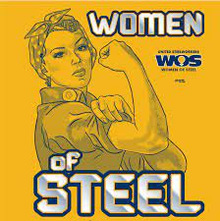 ξ 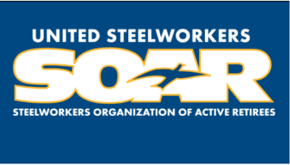

ξ Meetings held monthly (every third Thursday- 3:30 p.m.) at the Union Hall.

