June 2023 U.S.W. 11-75 Monthly Newsletter Volume 06
Our Motto…
- Be Safe, Be on Time.
- Everyone deserves a Respectful workplace.
Hard Core Anniversaries
Wayne Wilgren - 36 years
Graham Pooley - 31 years
Brian Bell - 13 years
Justin Watkins - 11 years
Mike Skoff - 10 years
Jon Ahlgren - 10 years
Bob Schueller - 10 years
Jeff Thomsen - 10 years
Craig Brown - 9 years
Adam Hager - 9 years
Found yourself in a pinch? Don’t go in alone- use your:
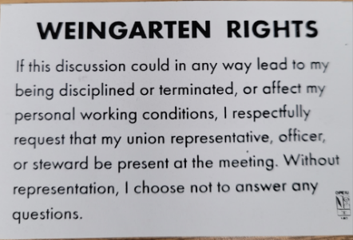
USW 11-75 QR code for updates.
What’s new
1285 Minnehaha Avenue E. St. Paul, MN. 55106 (651) 774-5943
Local 11-75 (uswlocals.org) : District 11 | United Steelworkers (usw.org)
News-Splash_______________________________________________________
- Stewards are your first point of contact for all Union Inquiries.
- Employee Sale @ 424- June 27, 28 & 29 from 6 a.m. to 5 p.m. each day.
If you are not familiar, it is worth checking out @ 1024 Hazel St.- St. Paul.
- Veterans of Steel, ROLL CALL- please contact Brandon Korkowski of the Veterans’ Committee, to claim/ update your military profile.
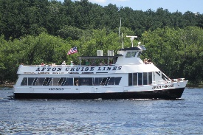 St. Croix River Cruises- The Afton Princess
Summer Event, Local 11-75: Friday, September 8th from 6:30 p.m. to 9:30 p.m.
Invitation for Member + Guest (early sign- up mandatory, see E-Board Rep.).
- MUST BE ON TIME- boarding window begins @ 6pm.
- Food is $19.95 per person (upfront w/sign up) and cash bar offered.
- We are thrilled to present, come & help us celebrate our 75th Birthday!
The Afton Princess is located at: 98 Walnut Street- Hudson, WI 54022 https://stcroixrivercruises.com/private-charters/cruise-lines
Proud Supporters of:
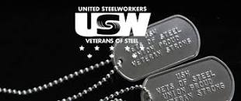 ξ 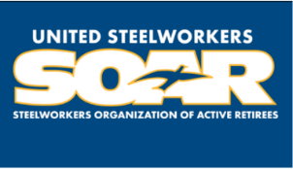

ξ Meetings held monthly (every third Thursday- 3:30 p.m.) at the Union Hall.

