July 2023 U.S.W. 11-75 Monthly Newsletter Volume 07
- Be Safe, Be on Time.
- Everyone deserves a Respectful Workplace.
-New Hires-
Please welcome: Dylan Heiple & Brian Franzen- our new Equipment Operators @ 424/450 warehouse.
USW 11-75 QR code for updates.
----------------------------------------
-Hard Core Anniversaries-
Tom Trudeau - 33 years
Keith Clemen - 11 years
Chris Schwake - 9 years
Shawn Kelley - 9 years
Rick Reinardy - 9 years
Rudy Lamprecht - 9 years

Found yourself in a pinch? Don’t go in alone- use your:
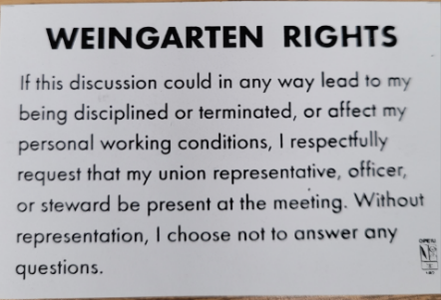
What’s new
1285 Minnehaha Avenue E. St. Paul, MN. 55106 (651) 774-5943
Local 11-75 (uswlocals.org) : District 11 | United Steelworkers (usw.org)
News-Splash_______________________________________________________
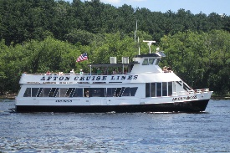 St. Croix River Cruises- The Afton Princess
Summer Event, Local 11-75: Friday, September 8th from 6:30 p.m. to 9:30 p.m.
Invitation for Member + Guest (early sign- up mandatory, see any E-Board Rep.).
- MUST BE ON TIME- boarding window begins @ 6pm.
- Food is $19.95 per person (upfront w/sign up) and cash bar offered.
- We are thrilled to present, come & help us celebrate our 75th Birthday!
The Afton Princess is located at: 98 Walnut Street- Hudson, WI 54022 https://stcroixrivercruises.com/private-charters/cruise-lines
- Please monitor your Paystub “Overtime”. Make sure all hours are @ 1.5x pay.
- Stewards are your first point of contact for all Union Inquiries.
- Roof update @ Union Hall: Materials have been installed and it looks Great!
- Second- half of Steward Training is in preparation stage for late summer.
- Accessing internal sites from a non-3M device is in developmental phase.
Proud Supporters of:
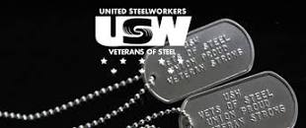 ξ 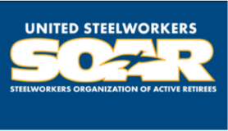

ξ Meetings held monthly (every third Thursday- 3:30 p.m.) at the Union Hall.

