October 2023 U.S.W. 11-75 Monthly Newsletter Volume 10
- Be Safe, Be on Time.
- Everyone deserves a Respectful Workplace.
-Hard Core Anniversaries-
Steve Heilmann - 32 years
.. Welcome Back Steve ..
Shelly Swanson - 15 years
Chad Seebeck - 13 years
Jason Schueller - 12 years

Take a moment to Thank a Steward.
They are your first point of contact for all Union Inquiries.
__________________________
Found yourself in a pinch? Don’t go in alone- use your:
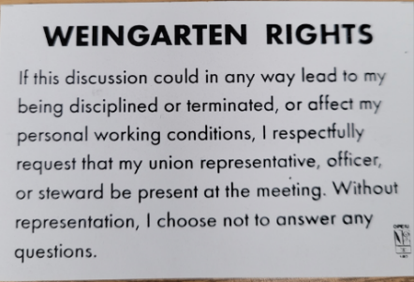
___________________________
USW 11-75 QR code for updates.

What’s new
1285 Minnehaha Avenue E. St. Paul, MN. 55106 (651) 774-5943
Local 11-75 (uswlocals.org) : District 11 | United Steelworkers (usw.org)
News-Splash_______________________________________________________
- Please monitor your Paystub “Overtime”. Make sure all hours are @ 1.5x pay.
- VA has extended the deadline to submit a claim for the PACT Act.
  - Powerpoint Presentation (va.gov).
  - What are the illnesses covered by PACT Act? (veteranlife.com).
  - The PACT Act and your VA benefits (Veterans Affairs).
- USW 11-75 has attended the last two Women of Steel WOS events: April 2023 in Cloquet, MN and August 2023 in Billings, MT.
- Accessing the Company network via a non-Company device.
  - Packet now circulated.
- Rapid Response is the Steelworkers’ nonpartisan grassroots education, communication and action program about pending legislation concerning labor and work-related issues. Hand-outs available or visit www.uswrr.org.
- Notify your Supervisor when you are leaving your designated building.
- USW@Work is the publication with A Powerful Voice for Workers.
For more information, please view the Publications Tab @ www.usw.org.
- Sonim phone connectivity or uniform quality problems?
Please contact Brenda Carlson @ 651-746-4347 or bscarlson@mmm.com
- Hot Glove rotation is drawing near, email will be sent with full details.
- Thank You to all who attended (many SOAR retirees) the Boat Cruise Fun!
Proud Supporters of:
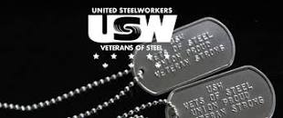 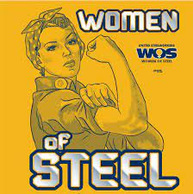 ξ 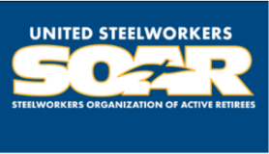

ξ Meetings held monthly (every third Thursday- 3:30 p.m.) at the Union Hall.

