November 2023 U.S.W. 11-75 Monthly Newsletter Volume 11



*Hard Core Anniversaries*

Andy Chrissis - 37 years

Rich Nordby - 34 years

Graham Pooley - 31 years

Myron Jurek - 10 years

Mark Millerbernd - 10 years

Kris Kauppi - 9 years

**Did you know?**

**USW@Work** is the publication with A Powerful Voice for Workers.Visit[www.usw.org](http://www.usw.org).

**_________________________**

Found yourself in a pinch?

Don’t go in alone- use your:

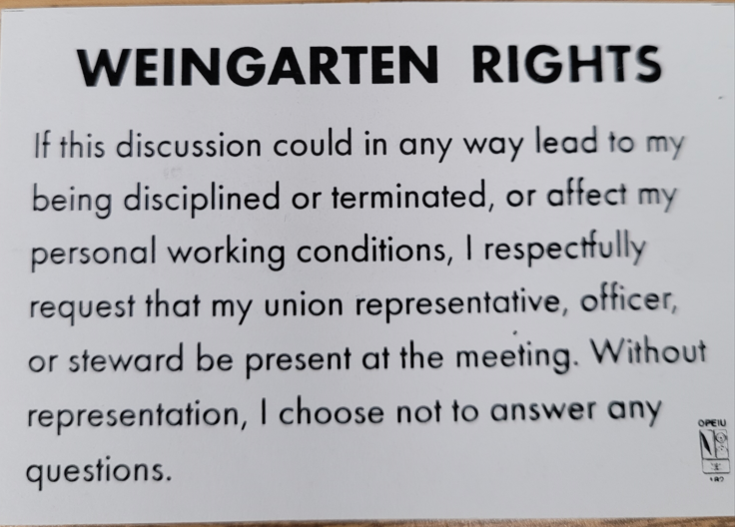

Take a moment to Thank a Steward.

**They are your first point of contact for all Union inquiries.**



USW 11-75 QR code for updates.

What’s new



**1285 Minnehaha Avenue E. St. Paul, MN. 55106 (651) 774-5943** [Local 11-75 (uswlocals.org)](https://uswlocals.org/local-11-75) : [District 11 | United Steelworkers (usw.org)](https://www.usw.org/districts/11)

**News-Splash**

* We are pleased to announce the U.S.W. Executive Board

**Trustee** position has been appointed to and accepted by: **Kevin Mach,** 235-Calibrations. Welcome aboard Brother Mach!

* Please monitor your paystub “Overtime” (all hours @ 1.5x pay).
* Accessing the network via a non-Company device- now circulated.
* *Rapid Response* is the Steelworkers’ nonpartisan grassroots education, communication and action program about pending legislation concerning labor and work-related issues.

Please visit [www.uswrr.org](http://www.uswrr.org). for further details.

* Grainger’s Shoe Truck on-site monthly.

**$225 for one transaction.** Don’t forget insoles.

* Stockroom order training (p: drive/ common/ stockroom).
* Utility Drivers are available to handle your parcels & shipments. Contact the 216 Stockroom or label [R4] and place on your Dock/Site Drop & Pick location (22 sites supported, placard below.)



Proud Supporters of:

 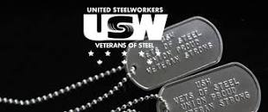  [1]ξ 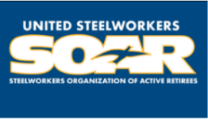

1. ξ **Meetings held monthly (every third Thursday- 3:30 p.m.) at the Union Hall.**