December 2023 U.S.W. 11-75 Monthly Newsletter Volume 12
-New Hires-
Please welcome: Joe McElhone (Millwright) & Chris McPherson (HVAC) to our 2nd Shift Crew.
_______________________________
Hard Core Anniversaries
Pat Wegleitner - 32 years
Joe Nauer - 9 years
_________________________
Found yourself in a pinch?
Don’t go in alone- use your:
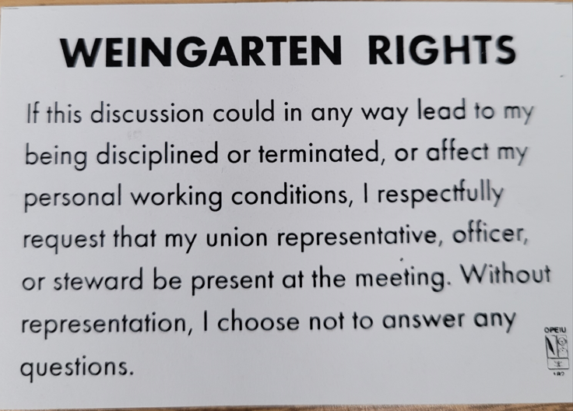
Did you know?
Rapid Response is the Steelworkers’ nonpartisan grassroots education, communication, and action program about pending legislation concerning labor and work-related issues.
Please visit www.uswrr.org. for details.
_____________________________
USW 11-75 QR code for updates.
WHAT’S NEW
1285 Minnehaha Avenue E. St. Paul, MN. 55106 (651) 774-5943 Local 11-75 (uswlocals.org) : District 11 | United Steelworkers (usw.org)
News-Splash
- Due to Holiday proximity, we will NOT hold a Hall Meeting 12/21.
- Holiday Potluck Celebration: December 13 @ your dedicated shop.
- District News: Emil Ramirez is the new USW Int’l Vice President.
Cathy Drummond makes history as USW’s first woman District Director, named to replace Emil Ramirez effective October 13th.
- Minnesota Safe & Sick effective Jan 1, 2024- M.O.U. in draft.
- Women of Steel took over downtown Pittsburgh in the last week of October. The International Women’s Conference is held every 3 years. Due to pandemic restrictions, this event has not occurred in the past six years. Workshops covering all aspects of building union strength. Educate and Know Your Power, Sisters.
- Notify your supervisor when you leave your designated building.
- Stewards are your first point of contact for all Union inquiries.
- Please monitor your paystub “Overtime” (all hours @ 1.5x pay).
- USW@Work is the publication for the workers- visit www.usw.org
- Accessing the network via a non-Company device- now circulated.
- Grainger Shoe Truck on-site monthly, $225 for one transaction.
Proud Supporters of:
ξ 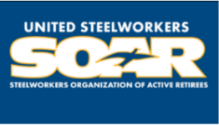

ξ Meetings held monthly (every third Thursday- 3:30 p.m.) at the Union Hall.

