January 2024 U.S.W. 11-75 Monthly Newsletter Volume 13



*Hard Core Anniversaries*

Tim Persico - 27 years

Marlowe Kokette - 14 years

Dan Sonday - 11 years

Mark MacDonald - 10 years

Chad Jacoway - 10 years

Mike Danich - 10 years

Dan Holmberg - 9 years

Brandon McKean - 9 years

**Did you know?**

USW@Work is the publication for the workers- visit [www.usw.org](http://www.usw.org)

USW 11-75 QR code for updates.

_____________________________

Found yourself in a pinch?

Don’t go in alone- use your:

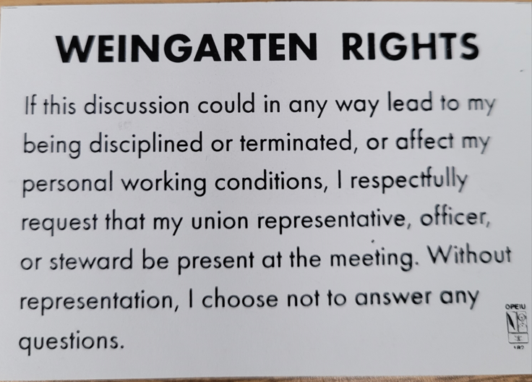

WHAT’S NEW



**1285 Minnehaha Avenue E. St. Paul, MN. 55106 (651) 774-5943** [Local 11-75 (uswlocals.org)](https://uswlocals.org/local-11-75) : [District 11 | United Steelworkers (usw.org)](https://www.usw.org/districts/11)

**News-Splash**

 Happy New Year 

* In 2024 many Members will enjoy their U.S.W. 10th year.
* Problems printing your WO’s? Contact 216 Stockroom for fix.
* Minnesota Safe & Sick effective Jan 1, 2024: quick reference
* 80 hours of **Paid** sick leave to frontloaded bucket.
* Can be used by the minute with no waiting period.
* New Steward appointment accepted by Chris Schwake in 236.
* U.S.W. Local 11-75 website has been updated, Check It Out!
* District News: Emil Ramirez- new USW Int’l Vice President.

Cathy Drummond makes history as USW’s first woman District Director named to replace Emil Ramirez on 10/13/23.

* Notify your supervisor when leaving your designated building.
* Please monitor your paystub “Overtime” (all hours @ 1.5x pay).
* Rapid Response is the Steelworkers’ nonpartisan grassroots education, communication, and action program about pending legislation concerning labor and work-related issues. [www.uswrr.org](http://www.uswrr.org).

Proud Supporters of:

 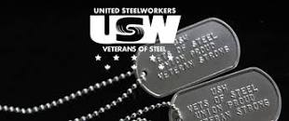  [1]ξ 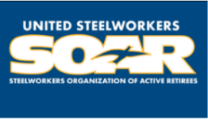

1. ξ **Meetings held monthly (every third Thursday- 3:30 p.m.) at the Union Hall.**