February 2024 U.S.W. 11-75 Monthly Newsletter Volume 14
Hard Core Anniversaries
Tim Ernst - 37 years
Chris Stewart - 9 years
T.J. DeMars - 9 years
Andy Gunderson - 9 years

A Piece of History
In 2005, USWA merges with PACE to become the largest manufacturing union in North America. The United Steel, Paper and Forestry, Rubber, Manufacturing, Energy, Allied Industrial and Service Workers International Union to be known forward as “United Steelworkers” (USW).
________________________________
In a pinch? Don’t go in alone- use your:
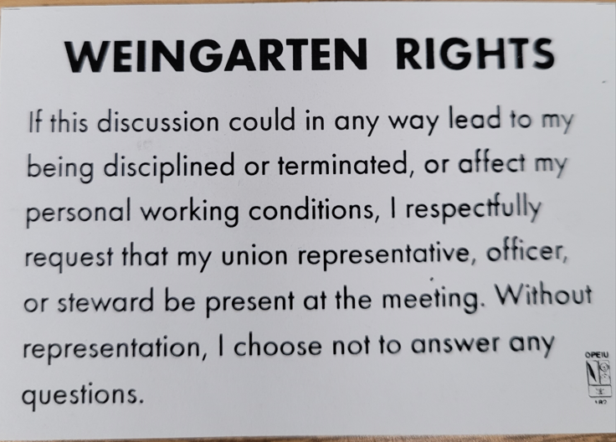

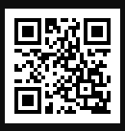
USW 11-75 QR code for updates.
WHAT’S NEW
1285 Minnehaha Avenue E. St. Paul, MN. 55106 (651) 774-5943 Local 11-75 (uswlocals.org) : District 11 | United Steelworkers (usw.org)
News-Splash
- Minnesota Safe & Sick effective Jan 1, 2024:
- 80 hours of Paid sick leave to frontloaded bucket.
- Can be used by the minute with no waiting period.
- Sick Time tracking via Workday: Notification system now in place when bucket falls to vital 16-hours and critical 8-hours. This will be accessible from home, via a non-3M device, see SOP/Steward.
- Take the time to “Enter Your Time”- Job Security Protection.
- Saving us monthly dollars- food and raffle will no longer be provided at regular scheduled monthly Hall meetings.
- Initial CBA signed on 02/24/1947. Happy 77th Birthday!
- Veterans: Community, Resources and Discounts thru www.va.gov
- Notify your supervisor when leaving your designated building.
- Please monitor your paystub “Overtime” (all hours @ 1.5x pay).
District News: Emil Ramirez- new USW Int’l Vice President. Cathy Drummond makes history as USW’s first woman District Director and officially replaced Emil Ramirez on 10/13/23. USW@Work is the publication for the workers- visit www.usw.org Rapid Response is the Steelworkers’ nonpartisan grassroots education, communication, and action program about pending legislation concerning labor and work-related issues. www.uswrr.org.
Proud Supporters of:
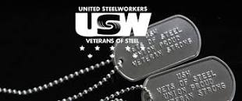 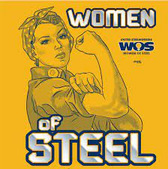 ξ 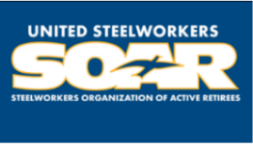

ξ Meetings held monthly (every third Thursday- 3:30 p.m.) at the Union Hall.

