May 2024 U.S.W. 11-75 Monthly Newsletter Volume 17
Hard Core Anniversaries
Greg Mjoen - 14 years
Tony Denzer - 12 years
Tom Schwich - 11 years
Bob Gordon - 10 years
Vicki Zimmerman - 10 years

In a pinch? Don’t go in alone, use your Weingarten Rights.
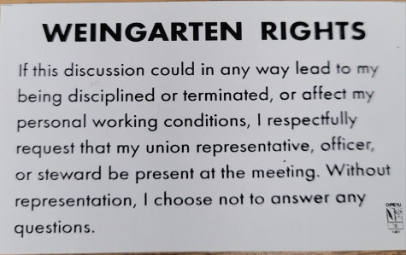_________________________________
Rapid Response is the Steelworkers’ nonpartisan grassroots education, communication, and action program about pending legislation concerning labor and work-related issues. www.uswrr.org.
_________________________________ A Piece of History
May Day, also called Workers' Day or International Workers' Day, is the day that commemorates the struggles and gains made by workers and the labour movement. It is observed in many countries on May 1.
WHAT’S NEW
1285 Minnehaha Avenue E. St. Paul, MN. 55106 (651) 774-5943 Local 11-75 (uswlocals.org) : District 11 | United Steelworkers (usw.org)
News-Splash
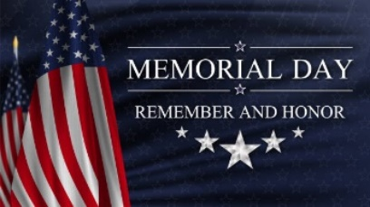 U.S.W. QR code- scan for updates.
- Memorial Day! Utilize your benefits wisely to maximize holiday pay.
- Uniform vendor changing this month: more information to come.
- Take the time to “Enter Your Time”- Job Security Protection
- Change your Outlook (email) “Retention Policy” before emails vanish.
- Minnesota Safe & Sick effective Jan 1, 2024:
- 80 hours of Paid sick leave to frontloaded bucket.
- Can be used by the minute with no-waiting-period.
- Sonim phone connectivity or uniform quality problems?
- Contact Brenda at (651) 746-4347 or bscarlson@mmm.com
- Please confirm product search with 216 Stockroom before pulling from Vendor machines.
- Accessing the Company network via a non-Company device= Circulated
- Please monitor your paystub “Overtime” (all hours @ 1.5x pay).
- Stewards are your first point of contact for all Union Inquiries.
USW@Work is the publication for the workers- visit www.usw.org
Proud Supporters of:
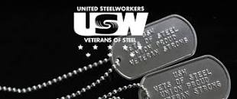 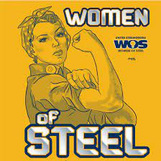 ξ 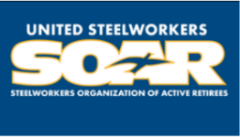

ξ Meetings held monthly (every third Thursday- 3:30 p.m.) at the Union Hall.

