-New Hire-
Please welcome:
Andrew Rocheford (Electrician) to the Plant Engineering Team.
____________________________
Hard Core Anniversaries
Wayne Wilgren - 37 years
Graham Pooley - 32 years
Jeff Thomsen - 26 years
Brian Bell - 14 years
Justin Watkins - 12 years
Mike Skoff - 11 years
Jon Ahlgren - 11 years
Bob Schueller - 11 years
Craig Brown - 10 years
Adam Hager - 10 years
Rick Denzer - 9 years
_______________________
Found yourself in a pinch?
Don’t go in alone- use your:

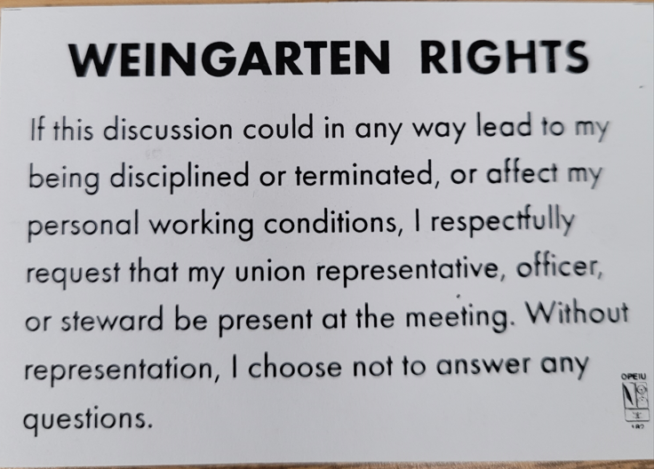
A Piece of History
John F. Kennedy sign the Equal Pay Act on June 10, 1963. An amendment to the Fair Labor Standards Act, this law is intended to end wage disparities between the sexes.

WHAT’S NEW

News-Splash
June 2024 U.S.W. 11-75 Volume 18

- Uniform vendor “UniFirst” is implementing latest changes. Communicate any sizing problems through your Supervisor.
- Take the time to “Enter Your Time”- Job Security Protection.
- Change your Outlook “Retention Policy” before emails vanish.
- Notify your Supervisor when you leave your designated building.
- Minnesota Safe & Sick effective Jan 1, 2024.
- Stewards are your first point of contact for all Union inquiries.
- Please monitor your paystub “Overtime” (all hours @ 1.5x pay).
- Grainger’s Shoe Truck on-site; allowed $225 for one transaction.
- Accessing the network via a non-Company device: now circulated.

USW@Work is the publication for the workers- visit www.usw.org

Rapid Response is the Steelworkers’ nonpartisan grassroots education, communication, and action program about pending legislation concerning labor and work-related issues. Please visit www.uswrr.org for details.
USW 11-75 QR code for updates.
Proud Supporters of:
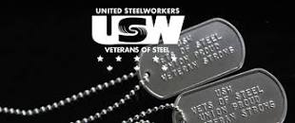 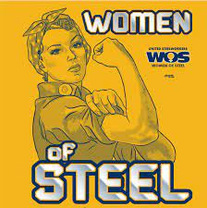 ξ 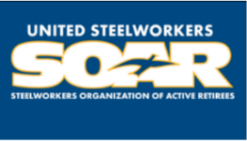

ξ Meetings held monthly (every third Thursday- 3:30 p.m.) at the Union Hall.

