Please welcome:

Joseph Folkers (Fitter) to the 2nd-Shift Plant Engineering Maintenance Team.

____________________________

********

*Hard Core Anniversaries*

Tom Trudeau - 34 years

Keith Clemen - 12 years

Ryan Wozniak - 11 years

Chris Schwake - 10 years

Shawn Kelley - 10 years

Rick Reinardy - 10 years

Rudy Lamprecht - 10 years

Mike Bambenek - 10 years

**_______________________**

**A Piece of History**

L.B.J. signs the Civil Rights Act- 7/02/1964. This act outlaw’s workplace discrimination.

Bloody Friday 7/20/1934: The Minneapolis Teamsters strike. 67 striking truckdrivers and their supporters were shot by Minneapolis police, acting on orders from the Citizens Alliance. _______________________________________ Found yourself in a pinch? Don’t go in alone- use your:

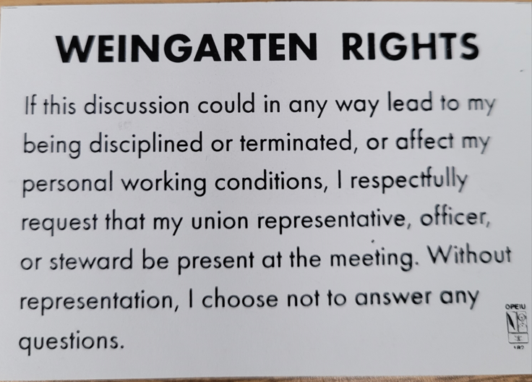

WHAT’S NEW

*News-Splash*

July 2024 U.S.W. 11-75 Volume 19

**Be Safe & Happy 4th of July**

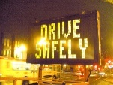

[This Photo](https://www.flickr.com/photos/tma/382846409) by Unknown Author is licensed under [CC BY-NC](https://creativecommons.org/licenses/by-nc/3.0/)

[This Photo](https://courses.lumenlearning.com/englishforbusiness/chapter/3-1-commonly-confused-words/) by Unknown Author is licensed under [CC BY-SA-NC](https://creativecommons.org/licenses/by-nc-sa/3.0/)

* All Dock Entries: REQUIRE Hi-Visibility Vests beginning July 1st.
* Uniform vendor “UniFirst” is implementing the latest changes. Communicate any sizing problems through Label in locker room.
* Minnesota Safe & Sick effective Jan 1, 2024.
* Stewards are your first point of contact for all Union inquiries.
* Please monitor your paystub “Overtime” (all hours @ 1.5x pay).

Get U.S.W. event info, news alerts and your union card right on your smart phone with our new United Steelworkers app! This free application can be downloaded for Apple users at the App Store (use.to/apple) or for Android users at the Google Play Store (use.to/android).

USW@Work is the publication for the workers- visit [www.usw.org](http://www.usw.org)

*Rapid Response* is the Steelworkers’ nonpartisan grassroots education, communication, and action program about pending legislation concerning labor and work-related issues. Please visit [www.uswrr.org](http://www.uswrr.org) for details.

USW 11-75 QR code for updates.

Proud Supporters of:

 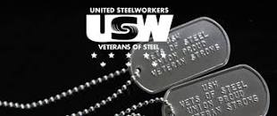 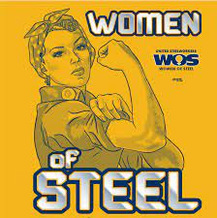 [1]ξ 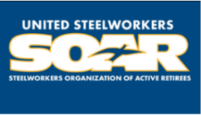

1. **ξ Meetings held monthly (every third Thursday- 3:30 p.m.) at the Union Hall.**