********

*Hard Core Anniversaries*

Bill Wittner - 37 years

Gary Blom - 37 years

Jim Ahlstrand - 35 years

Scott Carlson - 28 years

Tom Plourde - 17 years

Jim Schwartz - 13 years

Nate Vogt - 11 years

Paul Volkert - 10 years

Scott Taylor - 10 years

Joe Klenner - 09 years

Scott Persons - 09 years

___________________________________________

**A Piece of History**

**1924:** Mud and water from a nearby lake flood the Milford Mine near Crosby, Minnesota, drowning 41 of the 48 men working underground. It is the worst mining disaster in Minnesota history. **1924:** Under the federal Indian Citizenship Act, Native Americans gain the right to vote.

____________________________________Found yourself in a pinch?

Don’t go in alone- Use Your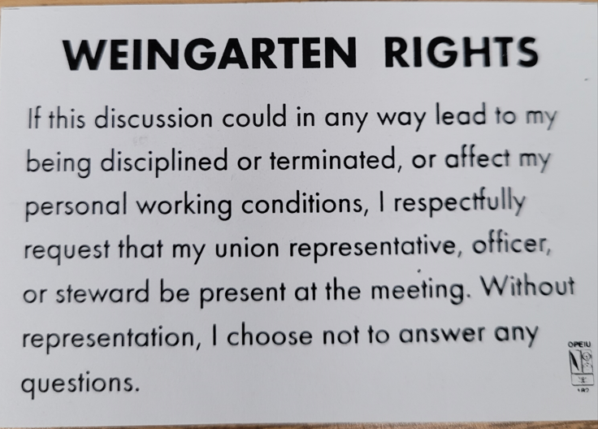

WHAT’S NEW

*News-Splash*

August 2024 U.S.W. 11-75 Volume 20

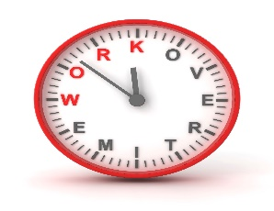

[This Photo](https://jobsanger.blogspot.com/2018/01/trump-administration-fails-to-protect.html) by Unknown Author is licensed under [CC BY-NC-ND](https://creativecommons.org/licenses/by-nc-nd/3.0/)

Overtime cancelled the same day/week is FORFEIT- Failure for our Team!

This is a Union Negotiated Benefit- and the expectation is:

You Scheduled It- You Work It (VOT/ AVOT whole shift).

Canceling overtime the week before- allows those hours back into bucket. Keep in good with your Brothers who are not offered shut-downs/ call-ins.

Frequent offenders earn Union discussion. Don’t Be “THAT GUY”.

* Minnesota State Fair U.S.W. Booth- Volunteers Needed. Interested?
* CUT-3-GLOVES are now the minimum requirement for hand safety.
* All Dock Entries: REQUIRE Hi-Visibility Vests beginning July 1st.
* Uniform sizing problems? Use Orange Label in locker room.
* Stewards are your first point of contact for all Union inquiries.
* Monitor your paystub “Overtime” (Company’s not watching for you).

Get U.S.W. event info, news alerts and your union card right on your smart phone with our new United Steelworkers app! This free application can be downloaded for Apple users at the App Store (use.to/apple) or for Android users at the Google Play Store (use.to/android).

USW@Work is the publication for the workers- visit [www.usw.org](http://www.usw.org)

*Rapid Response* is the Steelworkers’ nonpartisan grassroots education, communication, and action program about pending legislation concerning labor and work-related issues. Please visit [www.uswrr.org](http://www.uswrr.org) for details.

Proud Supporters of:

 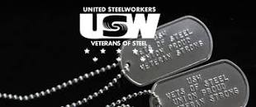 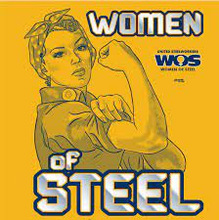 [1]ξ 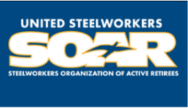

1. **ξ Meetings held monthly (every third Thursday- 3:30 p.m.) at the Union Hall.**