********

*Hard Core Anniversaries*

Joe Nauer - 10 years

Found Yourself in a pinch? Don’t go in alone- Use Your WEINGARTEN RIGHTS!

______________________________

**A Piece of History**

**Knights of Labor 12/28/1869**

It was founded by Uriah Stephens in Philadelphia, Pennsylvania on December 28, 1869; reaching 28,000 members by 1880.  **North America's first true international labor organization and the earliest practitioner of "industrial unionism"**.  It originated as a secret organization meant to protect its members from employer retaliations. Secrecy also gave the organization an emotional appeal.  Credited with having coined the phrase, "an injury to one is the concern of all". in 1879,.

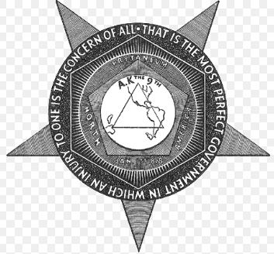

WHAT’S NEW

*News-Splash*December 2024 U.S.W. 11-75 Volume 24

Dream of a white Christmas. But if the white runs out, drink the red.

* Christmas! Utilize your benefits wisely to maximize holiday pay.
* CUT-9-GLOVES are now the minimum requirement for hand safety.
* Holiday Meal: Cub Foods catered on December 18th (1-hour lunch).
* Employee Sale: December 10th, 12th & 13th -Great Stocking Stuffers.

Overtime cancelled the same day/week is FORFEIT- Failure for our Team!

This is a Union Negotiated Benefit- and the expectation is:

You Scheduled It- You Work It (VOT/ AVOT whole shift).

Canceling overtime the week before- allows those hours back into bucket.

This must be performed before end of shift- every Thursday.

Get U.S.W. event info, news alerts and your union card right on your smart phone with our new United Steelworkers app! This free application can be downloaded for Apple users at the App Store (use.to/apple) or for Android users at the Google Play Store (use.to/android).

USW@Work is the publication for the workers- navigate to [www.usw.org](http://www.usw.org)

*Rapid Response* is the Steelworkers’ nonpartisan grassroots education, communication, and action program about pending legislation concerning labor and work-related issues. Please visit [www.uswrr.org](http://www.uswrr.org) for details.

Proud Supporters of:

 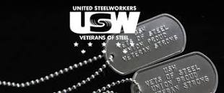 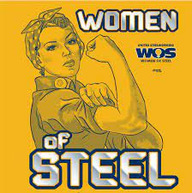 [1]ξ 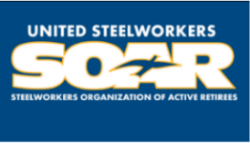

1. **ξ Meetings held monthly (every third Thursday- 3:30 p.m.) at the Union Hall.**