********

*Hard Core Anniversaries*

Tim Persico - 28 years

Marlowe Kokette - 15 years

Dan Sonday - 12 years

Mark MacDonald - 11 years

Chad Jacoway - 11 years

Mike Danich - 11 years

Dan Holmberg - 10 years

Brandon McKean - 10 Years

Found Yourself in a pinch?

Don’t go in alone- Use Your WEINGARTEN RIGHTS!

______________________________

**A Piece of History**

**Martin Luther King Jr. Day 1/15**

Dr. King was a prominent and prolific writer and public speaker throughout his life. We honor and celebrate his Birthday on January 15th.

WHAT’S NEW

*News-Splash*January 2025 U.S.W. 11-75 Volume 25



[This Photo](https://www.christmasstockimages.com/free/new_year/slides/happy_new_year_color.htm) by Unknown Author is licensed under [CC BY](https://creativecommons.org/licenses/by/3.0/)

“May the New Year bless you with health, wealth, and happiness.”

* New Year! Utilize your benefits wisely to maximize holiday pay.
* Whirlpool Inside Pass? It is real, multi- appliance bundle discounts!
* *Veterans:*Community, Resources & Discounts thru www.va.gov.
* Please monitor your paystub “Overtime” (all hours @ 1.5x pay).
* Notify your supervisor when leaving your designated building.

Overtime cancelled the same day/week is FORFEIT- Failure for our Team!

This is a Union Negotiated Benefit- and the expectation is:

You Scheduled It- You Work It (VOT/ AVOT whole shift).

Canceling overtime the week before- allows those hours back into bucket.

This must be performed before end of shift- every Thursday.

U.S.W. Local 11-75 Updates QR Code

Get U.S.W. event info, news alerts and your union card right on your smart phone with our new United Steelworkers app! This free application can be downloaded for Apple users at the App Store (use.to/apple) or for Android users at the Google Play Store (use.to/android).

USW@Work is the publication for the workers- navigate to [www.usw.org](http://www.usw.org)

*Rapid Response* is the Steelworkers’ nonpartisan grassroots education, communication, and action program about pending legislation concerning labor and work-related issues. Please visit [www.uswrr.org](http://www.uswrr.org) for details.

Proud Supporters of:

 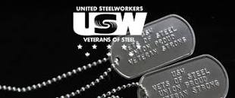 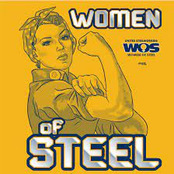 [1]ξ 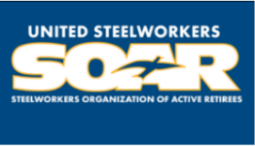

1. **ξ Meetings held monthly (every third Thursday- 3:30 p.m.) at the Union Hall.**