Please welcome: **Matthew Berdahl** *Operator* and **Faraeh Awale** *Systems* to our Plant Engineering Team.

____________________________

************

*Hard Core Anniversaries*

Tim Ernst - 38 years

Chris Stewart - 10 years

T.J. DeMars - 10 years

Andy Gunderson - 10 years

Found Yourself in a pinch?

Do not go in alone- Use Your WEINGARTEN RIGHTS!

______________________________

**A Piece of History**

**Back in 1925**

Jan 1: Edwin Hubble reveals Galaxies beyond Milky Way.

Feb 21: DNA Structure Discovery Breakthrough- molecular genetics.

Oct 1: Mount Rushmore Dedication Ceremony.

Oct 18: Grand Ole Opry launches in Nashville, Tennessee.

WHAT’S NEW

*News-Splash*February 2025 U.S.W. 11-75 Volume 26

**Happy 78th Birthday to U.S.W. Local 11-75.** Est. 2/24/1947

* U.S.W. CBA Negotiations coming soon, return Surveys by Feb 14th.
* Hot Gloves are almost due, anticipate email and rotate promptly.
* empower.com/3M see our Financial Wellness Summary leaflet.
* Whirlpool Inside Pass? It is real, multi- appliance bundle discounts!
* P.E. to P.E. packages & pallets- utilize Stockroom Drivers.
* Stewards are your first point of contact for all Union inquiries.
* Please monitor your paystub “Overtime” (all hours @ 1.5x pay).
* Accessing internal sites from a non-3M device: see revised procedure.

Overtime cancelled the same day/week is FORFEIT- Failure for our Team!

This is a Union Negotiated Benefit- and the expectation is:

You Scheduled It- You Work It (VOT/ AVOT whole shift).

Canceling overtime the week before- allows those hours back into bucket.

This must be performed before end of shift- every Thursday.

U.S.W. Local 11-75 Updates QR Code

Get U.S.W. event info, news alerts and your union card right on your smart phone with our new United Steelworkers app! This free application can be downloaded for Apple users at the App Store (use.to/apple) or for Android users at the Google Play Store (use.to/android).

USW@Work is the publication for the workers- navigate to [www.usw.org](http://www.usw.org)

*Rapid Response* is the Steelworkers’ nonpartisan grassroots education, communication, and action program about pending legislation concerning labor and work-related issues. Please visit [www.uswrr.org](http://www.uswrr.org) for details.

Proud Supporters of:

 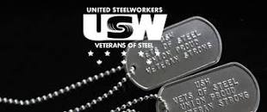 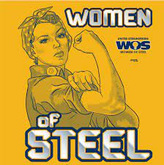 [1]ξ 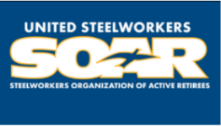

1. **ξ Meetings held monthly (every third Thursday- 3:30 p.m.) at the Union Hall.**