************

*Hard Core Anniversaries*

Mark Petzoldt - 35 years

Tom Plourde - 18 years

Joe Klenner - 10 years

Local 11-75 QR Code

Found Yourself in a pinch?

Do not go in alone- Use Your WEINGARTEN RIGHTS!

______________________________

**A Piece of History**

**Minnesota in 1925**

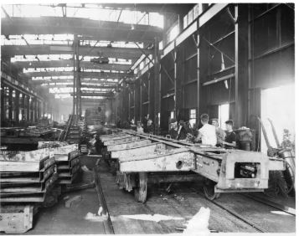

Repair shops of The Great Northern Railway- ¼ of the nation’s miles of freight track passed through Saint Paul. Traffic through Union Depot peaked in the 1920’s with 20K passengers stepping on/off nearly 300 trains each day. Railroads were the most powerful industry in the country at this time.

WHAT’S NEW

*News-Splash*March 2025 U.S.W. 11-75 Volume 27

* 110 Survey submissions: #1= Wages, #2= 401K/Pension, #3= Insurance.
* A.E.D. (defibrillator) locations by Building- list sent to Stewards.
* empower.com/3M see our Financial Wellness Summary leaflet.
* Stewards are your first point of contact for all Union inquiries.
* Please monitor your paystub “Overtime” (all hours @ 1.5x pay).
* Accessing internal sites from a non-3M device: see revised procedure.
* Whirlpool Inside Pass? It is real, multi- appliance bundle discounts!
* Grainger Shoe Truck onsite monthly - *$225 for one transaction*.
* P.E. to P.E. packages & pallets- *utilize Stockroom Drivers* along with the 20 supported locations using the placard below.

Overtime cancelled the same day/week is FORFEIT- Failure for our Team!

This is a Union Negotiated Benefit- and the expectation is:

You Scheduled It- You Work It (VOT/ AVOT whole shift).

Canceling overtime the week before- allows those hours back into bucket.

This must be performed before end of shift- every Thursday.

Get U.S.W. event info, news alerts and your union card right on your smart phone with our new United Steelworkers app! This free application can be downloaded for Apple users at the App Store (use.to/apple) or for Android users at the Google Play Store (use.to/android).

USW@Work is the publication for the workers- navigate to [www.usw.org](http://www.usw.org)

*Rapid Response* is the Steelworkers’ nonpartisan grassroots education, communication, and action program about pending legislation concerning labor and work-related issues. Please visit [www.uswrr.org](http://www.uswrr.org) for details.

Proud Supporters of:

 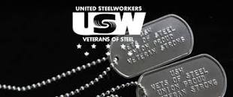 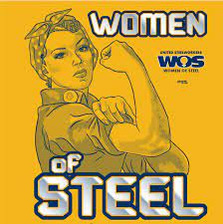 [1]ξ 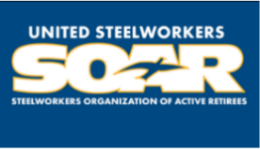

1. **ξ Meetings held monthly (every third Thursday- 3:30 p.m.) at the Union Hall.**